**Blood Pressure @ Home initiative standard operating procedure for the regional stroke pathway**

This procedure has been adapted from the NHS England Novel coronavirus (COVID-19) standard operating procedure: Blood pressure (BP) monitoring @home for people with diagnosed hypertension. It should be used in conjunction with the existing network procedure for BP Management (appendix 1) and local clinical policies.

1. **Target patient populations (see appendix 2)**

Community Stroke Teams should identify the following target patient populations for potential inclusion in the initiative:

* *Group 1:* Patients who are clinically extremely vulnerable (CEV; previously referred to as the shielding population) and have a last recorded systolic BP ≥130 mmHg and/or diastolic BP ≥80 mmHg, and are known to have paroxysmal or persistent AF.
* *Group 2:* Patients who are CEV, have previously had a stroke or transient ischaemic attack (TIA), have a last recorded systolic BP ≥130 mmHg and/or diastolic BP ≥80 mmHg, and do not already have a diagnosis of atrial fibrillation (AF).
* *Others:* Patients with BP ≥ 130/80 with history of recurrent stroke, coronary heart disease, peripheral vascular disease, diabetes or chronic kidney disease with eGFR < 60 ml/min

NB: Significant carotid stenosis/occlusion threshold BP is ≥150/90 mmHg

1. **Patients without access to a BP monitor**

* *Group 1* should be provided with a basic BP monitor and an appropriately sized cuff
* *Group 2* should be provided with a BP monitor that detects AF and an appropriately sized cuff

Prioritisation should be based on social deprivation including black, Asian and minority ethnic (BAME) demographics and age 65 years and over.

Where possible, monitors should be provided to patients on the basis that they will be returned to the team for reuse (following relevant infection control procedures) when there is no longer any benefit to the patient. Patients should be encouraged to purchase their own monitor if they are able.

If the patient declines to participate in the BP@Home initiative then alternative ways of regularly measuring their BP face-to-face should be pursued.

1. **Patients with access to a BP monitor**

The clinician should ensure that the patient’s BP monitor is both:

* Validated for home use (see list on the British and Irish Hypertension Society website: <https://bihsoc.org/bp-monitors/for-home-use/>)
* Working and less than five years old
* Have the correct size cuff to fit their upper arm

1. **Education**

The patient and/or carer should be educated on how to use the BP monitor and how to submit BP readings, and given supporting information.

* *Taking BP measurements:* Patient/carer/stroke team to take BP measurements for preferably 4 consecutive days. It should be measured after 3 minutes sitting and repeated again after 1 minute ideally in mornings before taking medication and in evenings.
* *Submitting BP measurements:* All readings should be submitted by the patient to the Community Stroke Team via a method that suits their needs which may take account of cognitive impairment or digital exclusion.

Patients should be told that if they record consecutive BP readings ≥170/115 mmHg, they should repeat 3 further readings after sitting quietly for half an hour and if still elevated ≥ 170/115, they should contact the GP practice for an urgent same day appointment for assessment and investigation. Readings can be recorded in a template by the patient (appendix 3).

1. **Data**

Teams should send all the readings plus the averages for each time interval to the patient’s GP so that the data can be uploaded to their clinical record which will enable evaluation of the initiative by NHS England. SNOMED codes specific to home BP monitoring should be used to code BP readings received from patients.

Home BP multiple readings averaged:

* 314446007 |Average day interval systolic BP
* 314461008 |Average day interval diastolic BP

Anonymised data should also be submitted by each stroke team to the network to support evaluation of the initiative (appendix 4). Data should also be collected by the team on the number of visits and resources required to enable a retrospective review of the initiative.

1. **Follow-up and liaison with primary care**

The average of the submitted readings should be calculated. Patients who report a:

* *Raised BP*: Average ≥130/80 mmHg should be followed up by prescribing clinician.
* *Follow up:* Patients should be advised to submit the average of 4 days of BP readings starting 2 weeks after any change in medication. If the BP average remains above target then medication should be increased after 4 weeks and repeat BP measurements to be made 2 weeks after starting on higher dose and cycle repeated every month until their BP is adequately controlled and then, ideally, in six months but at least annually thereafter.
* *Normal BP* Average <130/80 mmHg should be reassured by text or telephone and reminded to submit BP reading again, ideally in six months, but at least annually thereafter.
* *Irregular pulse* These readings should be in triplicate and should be followed by a referral for investigation to confirm diagnosis of AF.

Patients should be discharged when their BP is within the normal range (4 weeks after last normal reading) and there are no ongoing therapy needs.

If a GP has not adjusted medication following a request by the Community Stroke Team as the patient is outside of target range then the GP should be contacted on a further occasion for clarity as to why this has not been actioned to clarify this is due to appropriate clinical reasoning. Advice from a local stroke consultant could be sought if concerns persist, however, the medical management of the patient lies with the GP.

Unless urgent, then contact with GPs should ideally be via email to ensure appropriate documentation is retained.

1. **Care homes**

People living in care homes should receive the same standard of care as someone in their own home. Access to BP monitoring for patients in care home settings should be facilitated by care home staff and other supporting services. Support with setting up the pathway within the care home can be provided through the care home’s named clinical lead in the first instance.

**Appendix 1. GMISDN BP management pathway**



**Appendix 2.**

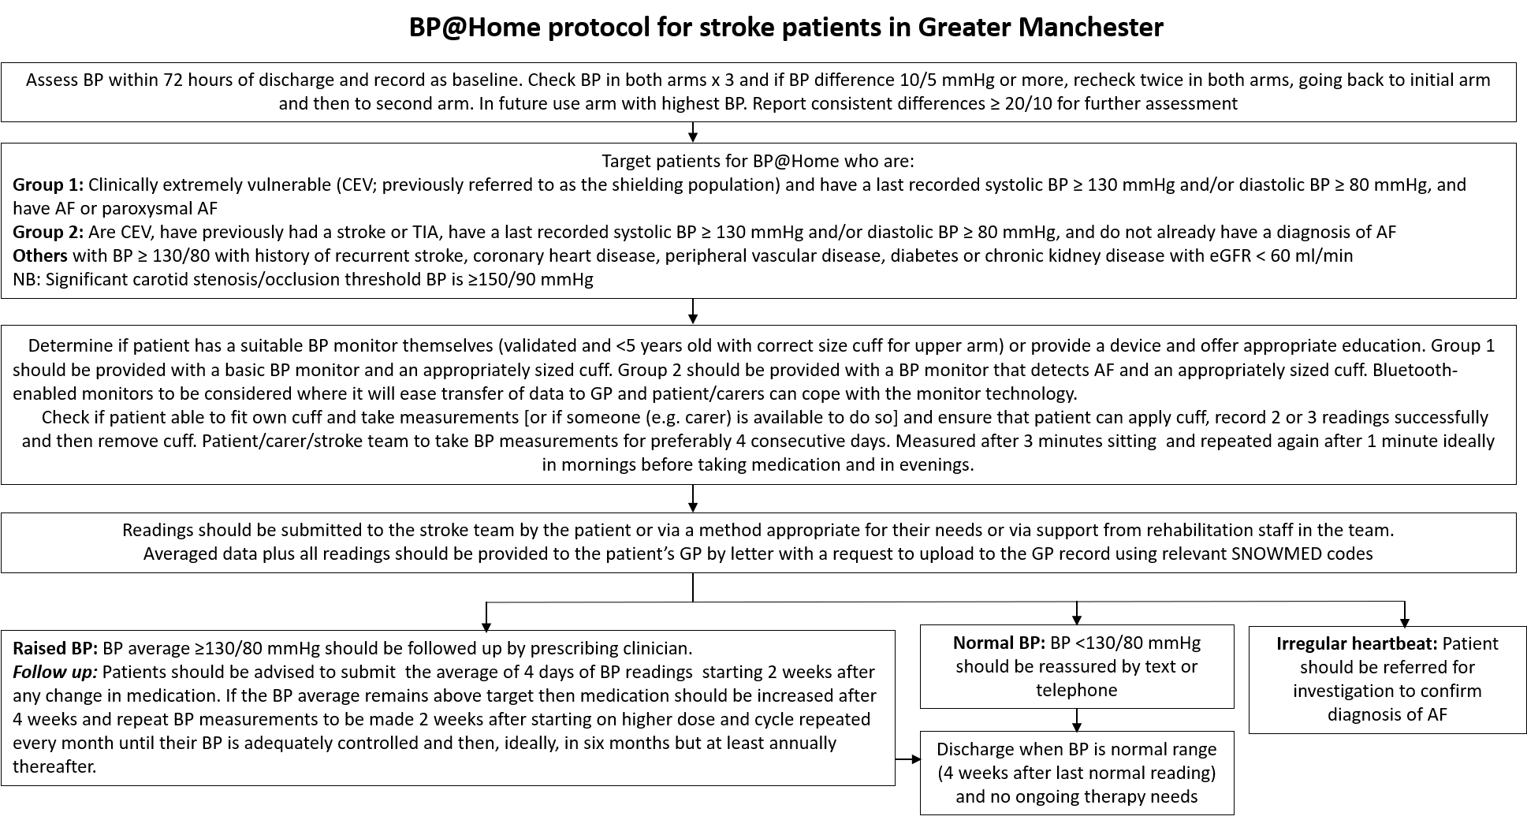

to GP care

**Appendix 3. Home Blood Pressure Diary Template**

**Home Blood Pressure Diary**

Your Name:

DOB:

Target Blood Pressure (if appropriate): lower than ……… / ……….

Initial reading: Left arm:…….. /………. Right arm:……..… /………..

Arm used:   Left       Right

Size of cuff: Small Medium Large

Please monitor and record your blood pressure at home for 4 consecutive days (unless you have been advised otherwise).

On each day, monitor your blood pressure on two occasions - in the morning (before your tablets) and again in the evening.

On each occasion take a minimum of two readings, leaving at least a minute between each. If the first two readings are very different, take 2 or 3 further readings. Make sure you sit quietly for 3 minutes before you take a reading.

Use the table below to record all of your blood pressure readings. The numbers you write down should be the same as those that appear on the monitor screen - do not round the numbers up or down.

In the comments section, you should also write down anything that could have affected your reading, such as feeling unwell or changes in your medication.

Remember to take this diary with you to your next appointment/review.

Please turn over to record your readings

|  |  |  |  |  |
| --- | --- | --- | --- | --- |
| **Date** | **Time** | **Top number (systolic)** | **Bottom number (diastolic)** | **Pulse** |
|  | **am** |  |  |  |
| **pm** |  |  |  |
|  | | | | |
|  | **am** |  |  |  |
| **pm** |  |  |  |
|  | | | | |
|  | **am** |  |  |  |
| **pm** |  |  |  |
|  | | | | |
|  | **am** |  |  |  |
| **pm** |  |  |  |
|  | | | | |
|  | **am** |  |  |  |
| **pm** |  |  |  |

**Appendix 4. GMISDN data collection tool**



**British Heart Foundation (BHF) resources and support**

The most relevant resources for this project are listed below; all of which can be accessed via the [Manage your blood pressure at home hub](https://www.bhf.org.uk/informationsupport/support/manage-your-blood-pressure-at-home) – a new hub created to help measure and manage blood pressure at home during the pandemic. All patients should be signposted to the hub in any communications sent out as part of the project.

|  |  |  |
| --- | --- | --- |
| **Tool or resource** | **Description** | **Format** |
| [How to measure blood pressure at home - video](https://www.bhf.org.uk/informationsupport/support/manage-your-blood-pressure-at-home#measure) | Video of a BHF senior cardiac nurse demonstrating to patients how to measure blood pressure at home. | Online video |
| [High blood pressure and coronavirus](https://www.bhf.org.uk/informationsupport/heart-matters-magazine/news/coronavirus-and-your-health#Heading2) | BHF medical experts answer questions about how COVID-19 can affect people with heart disease, including hypertension. | Webpage |
| [Six tips for reducing blood pressure](https://www.bhf.org.uk/informationsupport/heart-matters-magazine/research/blood-pressure/blood-pressure-tips) | Tips to help reduce your BP or control it following a diagnosis of BP. | Webpage |
| [Understanding blood pressure booklet.](https://www.bhf.org.uk/informationsupport/publications/heart-conditions/understanding-blood-pressure) | Booklet for people with high BP to help them understand the condition. Includies information on what high BP is and how to reduce it. | This is available to download or to order in print. |
| [Manage your blood pressure at home hub](https://www.bhf.org.uk/informationsupport/support/manage-your-blood-pressure-at-home) | Central hub for all resources for high BP. | Webpage |
| [Healthcare professional hub](https://www.bhf.org.uk/for-professionals/healthcare-professionals/resources-for-your-role) | A central hub of clinical tools and practical resources specific to healthcare professionals | Webpage |

#### Other patient resources

* Blood pressure monitoring template diary
* Blood Pressure UK: [Homepage](http://www.bloodpressureuk.org/Home)
* Stroke Association: [Risks of high blood pressure](http://www.stroke.org.uk/what-is-stroke/are-you-at-risk-of-stroke/high-blood-pressure)
* Bradford Healthy Hearts: [Homepage](https://www.bradfordshealthyhearts.co.uk/)