**Greater Manchester Individual Funding Requests & Permissible Activity**

**Guidance Document for Clinicians**

**October 2024**

**Introduction**

This guidance document is for Greater Manchester clinicians in stroke and neurorehabilitation. It supports clinicians in understanding the processes involved when considering Individual Funding Requests (IFRs) and Permissible Activity. The purpose of these guidelines is to ensure equitable access to treatments/products not routinely commissioned within NHS services.

**Definitions**

Permissible Activity

This refers to all treatments/products that were previously commissioned under ‘Monitored Approval’ or ‘Individual Prior Approval’ but are now classed as ‘Permissible Activity’. This refers to items that have a relevant GM Effective Use of Resources (EUR) Commissioning Statement due to a previously identified gap in commissioning (see additional information below for relevant policies).

This now means that if the patient meets the criteria within the relevant policy, clinicians no longer need to obtain approval before commencing treatment. Instead, the patient can be referred directly for treatment and treated in line with the policy criteria.

It is therefore the responsibility of the clinician involved in the patients care to check the patient’s eligibility against the policy criteria.

Independent Funding Requests

IFRs are applications for treatments or interventions that either do not meet the relevant EUR policy criteria OR where the treatment is not routinely available AND where it is believed that there is a genuine **exceptional** health care need.

**What’s Covered**:

* Guidance on selecting the appropriate route – IFR or permissible activity.
* Criteria for permissible activity based on GM Commissioning Statements.
* Step-by-step process for submitting applications via both routes.
* Guidance on gathering necessary information for applications.
* Information on managing invoices effectively.

**GM IFR/Permissible Activity Flow Chart**

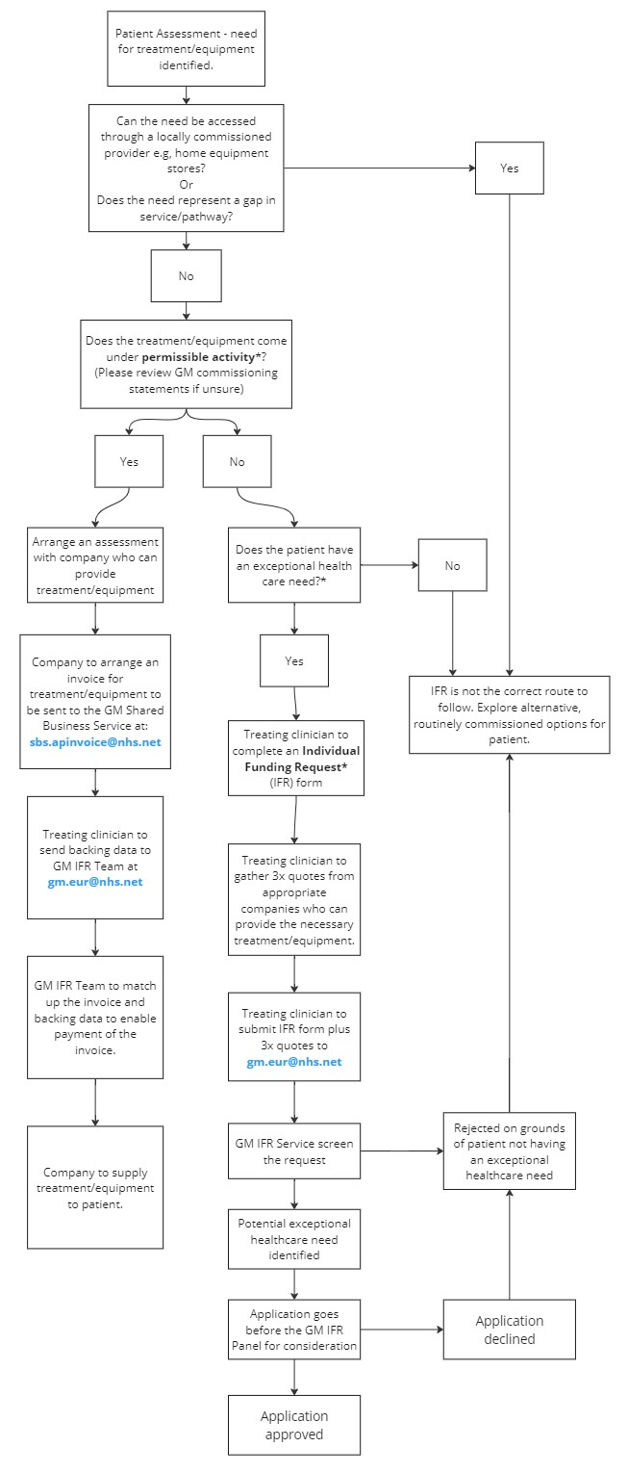

Additional Information

**Permissible Activity**

**GM Commissioning Statements**

The GM Commissioning Statements were produced to ensure appropriate, equitable access to low cost/low value treatments/products which were not otherwise routinely available within commissioned NHS services.

The statements relevant to GM neurorehabilitation and stroke services are:

* Functional Electrical Stimulation for Foot Drop
* Trophic Electrical Stimulation for Facial Palsy
* Orthoses, Bespoke Orthoses & 24-hour Posture Management
* Lycra Body Suits
* Cough Assist (Mechanical Insufflation and Exsufflation (MI-E)
* Non-Specialist Augmentative and Alternative Communication (AAC) AIDS

These policies outline the criteria whereby a treatment/product may be ‘permissible activity’ or not and can be found [here](https://www.gmeurnhs.co.uk/nhsgmgmicbblobstorage/GMEUR/GM%20Policies/GM%20EUR%20Policy%20descriptions%20and%20key%20words.pdf).

**Sourcing treatment/equipment:**

If the treating clinician does not have access to a treatment or piece of equipment within their team/stock, they must source this externally from an alternative provider. This may be a private company or another NHS provider.

If using a private company, then the treating clinician should arrange for them to assess the patient and provide an invoice for the treatment/product.

**Departments/Individuals Involved**

* NHS Shared Business Services (SBS) – They offer a range of services to help NHS organisations, one of these being invoice processing. Email: sbs.apinvoice@nhs.net Tel: 0113 307 1500.
* IFR Team – previously known as the EUR Team, this department within the Greater Manchester Integrated Care Board (GM ICB) deals with all IFR requests and invoices for permissible activity. They can be contacted on [gm.eur@nhs.net](mailto:gm.eur@nhs.net) or 0161 290 4901
* ‘Treating Clinician’ – refers to the individual clinician who is responsible for the patients referral and treatment.

**Invoicing**

Invoices should **not** contain patient identifiable information (e.g. name, NHS number, address etc). They must contain an invoice reference number (provided by the service/company submitting the invoice) and should also include the reference **XXQOPAGMIFRTEAM**

The company should provide one copy to the treating clinician and one to the Shared Business Service and one to the GM IFR Team ([gm.eur@nhs.net](mailto:gm.eur@nhs.net)).

The company should provide a copy to the treating clinician and a copy should be submitted for payment electronically to the following two email addresses: [sbs.apinvoice@nhs.net](mailto:sbs.apinvoice@nhs.net) and [gm.eur@nhs.net](mailto:gm.eur@nhs.net). This invoice should be addressed as follows:

NHS Greater Manchester ICB

QOP Payables N125

Phoenix House

Topcliffe Lane

Tingley

West Yorkshire

WF3 1WE

(N125 is the identifier for GM ICB, and allows the system to assign it to the correct NHS organisation)

**Backing Data**

Once a company has been identified and an invoice raised for the treatment/equipment required, the treating clinician should send a backing data email to GM IFR Team on [gm.eur@nhs.net](mailto:gm.eur@nhs.net) including the relevant information (see example below). Please attach a copy of the invoice to the email and include the intervention/item requested; invoice number including item cost & supplying company; date; patient initials and NHS number, statement regarding clinical reasoning from the treating clinician and confirmation that the patient meets the policy criteria. Confirm you have read and understand the policy. Please add onto the invoice the reference "XXQOPAGMIFRTEAM". This can either be placed at the top of the invoice or in the description box on the invoice.

Example email from Trafford CSNRT to GM IFR Team re. Backing data for a Dynamic Movement Orthosis

Re. Backing data for invoice/quotation reference number XXXXXXXXXX

Dear GM IFR Team

Please accept this backing data email for invoice/quotation reference number XXXXXXXXXXXXX for patient XX (initials only) with NHS number XXX XXX XXXX.

The invoice total cost is £ XXXX for item XXXX and the supplying company name for the invoice is XXXX. The date of the invoice is XXXXXX.

I can confirm that XX (initials only) meets the criteria for provision of a dynamic movement orthosis via the permissible treatment pathway as the garment will improve the proximal control in XXXX thus promoting biomechanical realignment for control of posture and increased functional independence. This fits the orthoses, bespoke orthoses, and 24 hour posture management policy which I have fully read and understood.

Many thanks in anticipation

Additional Information:

**Independent Funding Requests (IFR’s)**

These are applications for treatments or interventions that either do not meet the relevant EUR policy criteria OR where the treatment is not routinely available AND where it is believed that there is a genuine **exceptional** health care need.

The clinician should complete the application in full and must be able to demonstrate a strong case for how their patient is clinically exceptional to others who may also be requesting the treatment/intervention. An exceptional health care need focuses on the actual “health problem” of the patient rather than the individual patient themselves. This may include a rare/highly unusual presentation of a health condition a patient is diagnosed with. The application should include evidence and research papers supporting the uniqueness of the case and how the intervention will benefit the patient.

The GM IFR process only considers clinical information. As a central principle, the NHS does not make judgements about the worth of different individuals and seeks to treat everyone fairly and equitably. Non-clinical, personal, individual and social factors must be disregarded and not included in the application for this purpose in order for the GM IFR Clinical Triage Team and then the GM IFR Panel, to be confident of dealing in a fair manner in comparable cases. Therefore the application should not have any reference to personal, social or individual circumstances

**IFR Form:**

[Please visit the GM IFR Service website for most up to date form here](https://gmintegratedcare.org.uk/greater-manchester-individual-funding-request/)

**Invoicing**

Invoices should **not** contain patient identifiable information (e.g. name, NHS number, address etc). They must contain an invoice reference number (provided by the service/company submitting the invoice) and should also include the reference **XXQOPAGMIFRTEAM**

If the request has been approved by the GM IFR Team, the **IFR reference** should also be included on the invoice (this will be included in the funding approval letter).

The company should provide a copy to the treating clinician and a copy should be submitted for payment electronically to the following two email addresses: [sbs.apinvoice@nhs.net](mailto:sbs.apinvoice@nhs.net) and [gm.eur@nhs.net](mailto:gm.eur@nhs.net). This invoice should be addressed as follows:

NHS Greater Manchester ICB

QOP Payables N125

Phoenix House

Topcliffe Lane

Tingley

West Yorkshire

WF3 1WE

(N125 is the identifier for GM ICB, and allows the system to assign it to the correct NHS organisation)