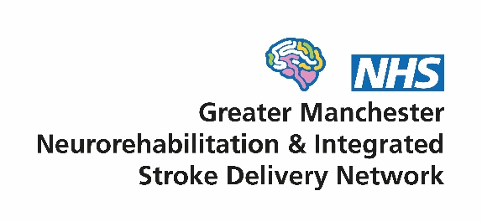
Patient and Carer Group
Minutes of the meeting
Date: 10am – 2pm Friday 28th November 2025
Held at St Matthews Hall, Stretford, M32 9AJ

People who attended the meeting:
Group chair: Nick Davies
Members: Aina, Edith, Caroline, Seth, Sonya, Helen, Kunle, Modupe and Mark
From the network: Sarah Rickard (Manager), Chris Ashton (Facilitator) and Debbie O’Halloran (Administrator)

People who gave apologies:
Mike, Deb D, Billy

Neighbourhood simulation
Helen shared her experience of being part of a simulation of neighbourhood working. It was part of the recent NHS Confederation conference attended by the health secretary Wes Streeting. Helen outlined that she played a character in a family that interacted with health and other public sector services. She enjoyed the experience and hoped that the public sector benefited from its insights.

Network update
Acceptance and Commitment Therapy
Sarah shared a recent training programme for clinical staff. It is called Acceptance and Commitment Therapy and it helps patients to deal emotionally with their situation. More information is in the slides below – double click on the icon.


NHS changes
Sarah talked about some of the work the network has been doing. She outlined that there were significant organisational changes underway locally in the Greater Manchester Integrated Health Board which controls the money spent locally on health. At the same time, NHS England is being abolished. These changes are causing disruption and may slow progress in improving services.

Digital
Sarah outlined that the network is setting up a digital task and finish group. It will bring together charities and NHS staff to shares ideas on better use digital technology in stroke and neuro care. Digital is a key plank in the new NHS 10 Year Plan for Health.

Transient Ischaemic Attack
Sarah shared work on improving Transient Ischaemic Attack services in the region. More information is in the slides.
The group noted that the method of assessment e.g. phone or face to face is important and should be discussed with stroke units. Using the phone can be difficult for some.

Self-management
Sarah updated on work to improve self-management. This is where patients and carers are given information and support to help them manage their condition better themselves. The network is working with the neuroscience centre at Salford to develop a digital platform. It was agreed that accessibility will be key, and formats like video work well with patients. Involving patients/carers in the co-design is also crucial.

Ambulances and data
Chris shared his work as a Facilitator in the network. He focuses on ambulance care and also using data to support service improvements. This was mostly the national stroke audit data as there is limited data for other neurological conditions. More information is in the slides.
Helen asked why data collection isn’t for longer. Chris explained that it would be much better if this happened, but no stroke data was collected beyond 6 months after a stroke.

- Any other business
It was agreed that we will invite a charity to attend and share what they do at each meeting. Mark offered to talk about Speakeasy next time as he also works for them.

The next Patient and Care Group Meeting is due to take place in March. The new 2026 dates will be sent out shortly

