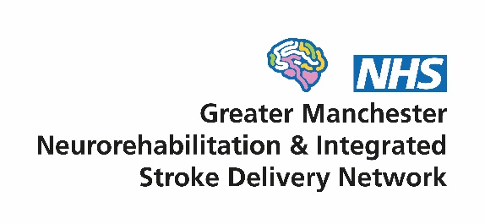
Patient and Carer Group
Minutes of the meeting
Date: 10am – 2pm Friday 6th March 2026
Held at St Matthews Hall, Stretford, M32 9AJ

People who attended the meeting:
Group chair: Mike Carpenter
Members: Aina, Maria, Darshana, Edith, Caroline, Seth, Sonya, Helen, Kunle, Nick, Billy and Mark
From the network: Sarah Rickard (Manager), Stuart McDarby (Community Lead) and Karen Smith (Administrator)
Other attendees: Fiona Davison from the Stroke Association

Introductions
Everyone introduced themselves including three new members – Dave, Darshana and Maria.
Maria had a brain aneurysm a few years ago and is involved with a Hereditary Brain Aneurysm charity called HBA. Darshana lives with Multiple Sclerosis and works with the MS Society. Dave has a spinal injury and works for the Spinal Injury Association.

Network update
Sarah noted it was the largest meeting we had ever had!
She then provided an update on some of the projects the network is working on. These are outlined in the embedded slides 7-18 below. Double click on the icon to open.
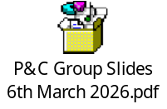
Sarah outlined that the network team is changing. Debbie will be leaving, along with two Facilitators Gemma and Farheen. It will be a smaller team going forwards.
Sarah led a discussion on what matters most to group members to help inform the network’s strategy and project plans. Below is a summary:
- Adjustment to Diagnosis & Living with a Neurological Condition
- Adapting to a 'new normal' after diagnosis is difficult
- Self-acceptance can take time and may require support
- Some neurological conditions are progressive, meaning adjustment is ongoing
- Recovery can feel like 'two steps forward, one step back'
- Loss of motivation and apathy can be part of the condition

- Mental Health Support
- Mental health challenges are common but often hidden
- Needs are not always recognised or addressed within neurological care

- Feeling Heard and Understood
- Patients sometimes feel that others do not understand their condition
- Symptoms are often attributed to the neurological condition and other medical problems can be missed
- Aphasia can make this worse
- Being listened to and taken seriously is very important

- Healthcare Experience & Dignity
- Experiences on hospital wards were mixed
- Some reported issues with dignity in care, especially from nurses
- Greater awareness of neurological patient needs could improve experiences

- Coordination of Care
- Care can feel fragmented between services
- Appointments often focus on physiotherapy while other needs may be overlooked
- Carers are not always included in care planning
- A case manager or coordinator could help connect services and reduce inefficiency

- Managing Multiple Conditions
- Many are managing more than one health condition
- Treatments for one condition can affect another
- More support in making treatment decisions across conditions would help

- Rehabilitation
- Rehabilitation services are valued and considered beneficial
- Access can sometimes be limited or inconsistent

- Community Lead role
Stuart provided a short overview about himself. He is the new network Community Clinical Lead. He is the team lead at the Bury Community Stroke and Neuro Team and is a Physiotherapist.

- Stroke Association
Fiona shared the work they do at a local and also national level. More information is in the slides below.

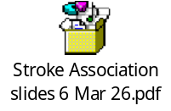

Development of an online self-management platform
Sarah led a discussion on what should be considered when the Northern Care Alliance NHS Trust develop a website to support greater use of self-management.
Slides 20-26 provide more information.
Key points from the discussion:
- Accessibility and Communication Needs
- Aphasia-friendly design is essential – simple language, short sentences, clear structure
- A visual focus using icons, symbols, diagrams, photos and minimal text per page
- Cognitive accessibility – information must be broken into manageable chunks, easy to navigate, and not overwhelming
- Avoid large text blocks and ensure the platform is not too information-heavy
- Consistent layout throughout helps users anticipate where content will be
- Language barriers and digital literacy challenges need to be considered; alternatives or support should be offered

- Trust, Reliability and Avoiding Misinformation
- Want a platform that acts as a safe alternative to “Googling”.
- Often encounter misinformation online and find it hard to judge trustworthy sources
- The platform must act as a signposted, reliable route to accurate Trusted sources such as NHS, charities etc
- Clear explanations of what different services do, and what is involved, should be provided
- Up-to-date content is critical and avoid broken or outdated links

- Navigation, Structure and User Journey
- Pages should be simple, clutter-free, and with minimal scrolling
- Short menus and clear signposting to key sections
- A clear start point (“If you’re newly diagnosed, start here”) may help
- Separate areas for patients, carers, condition-specific content
- A search function may help find information faster
- The ability to print or save information is important

- Content Priorities
- Who the local neuro teams are - roles, names, location, how they help
- Local services and what’s available – rehabilitation, voluntary sector, community groups, support groups etc
- Research updates – “what’s new?” “what’s coming?”
- FAQs on symptoms, recovery, equipment, social care processes
- Carer-specific advice, with space dedicated to their needs and responsibilities
- Financial help and benefits – signposting to IAS, legal support, welfare rights
- Practical guidance: what to expect, how to access services, how to self-manage day to day

- Digital Inclusion and Alternatives to Online Access
- Many users require support to get online due to cognitive difficulties, unfamiliarity, or financial constraints:
  - Signposting to community hubs, libraries, navigation services
  - Training or step-by-step “how to use this website” guides
- Printed information remains essential for some

- Practical Features and Tools Requested
- Print-friendly formats
- QR codes
- Ability to save personal notes or favourites (if feasible)
- A central “unique area” that consolidates all core information in one place
- An option to view content in a simplified or aphasia-friendly mode

- Engagement and Promotion
- Promotion through:
  - Clinicians across neuro, stroke and community services.
  - Patient groups
  - QR codes on leaflets and posters
- Ensure staff across the system are aware of the site so they can recommend it consistently

- Any other business
The agenda for next time will focus on developing a project plan for carers support, fatigue management. Dave will talk about spinal injury. A charity will be invited to speak.
Sarah shared that the network is currently visiting all stroke units. She asked if any members wanted to join these visits.
Billy and Maria volunteered to go to Salford. Nick offered to go to Tameside. Aina said she would attend at Stepping Hill. Mark offered to go to Bolton.

