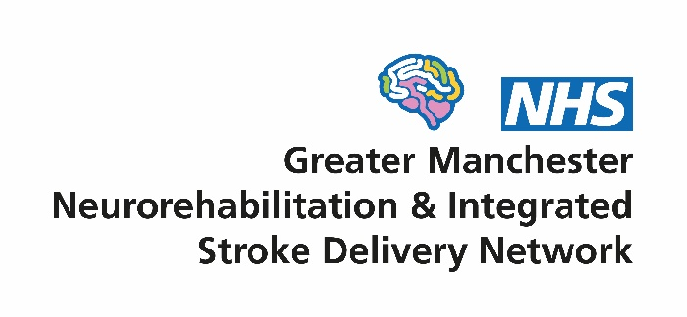
Board
Terms of Reference

- Context
Since 2015, there have been two networks in Greater Manchester (GM) overseeing service improvement of the local neuro-rehabilitation (NR) and stroke pathways - the GM Neuro-rehabilitation Network (NRN) and the GM Integrated Stroke Delivery Network (ISDN). The significant overlap of the work programmes of two networks coupled with a funding shortfall in the NRN budget led to a decision at both network Boards in mid 2021 to merge the organisations into a single structure. The merged network will be called the GM Neuro Rehabilitation & Integrated Stroke Delivery Network (GMNISDN) and formally commenced on 1st October 2021.
In 2020/21, 20 ISDNs were established by NHS England (NHSE) to lead the implementation of the Long Term Plan commitments for stroke. The networks will ensure effective delivery of high-quality stroke services and will support improvement across the whole patient journey. They are required to be accountable to their Integrated Care System (GM Health & Social Care Partnership) and the North West NHSE Senior Responsible Officer for CVD. On 1st October 2020, the GM Stroke Operational Delivery Network transitioned to the GMISDN in shadow form, before being fully established by the 1 April 2021.
GMNISDN will remain a non-statutory body hosted by Salford Royal NHS Foundation Trust (SRFT). It is constituted from key stakeholders including all GM and Eastern Cheshire NHS stroke providers as well as NHS organisations in GM providing community NR services. Other stakeholders include commissioners, North West Ambulance Service, the voluntary sector and patient and carer representation.

- Vision
Supporting the development of high quality and equitable stroke and community NR services, to achieve the best outcomes and experience for patients. We will do this by:
- Being patient centred
- Working collaboratively with our stakeholders
- Facilitating transformational change through effective partnership working
- Encouraging the early adoption of evidence and innovation in our services

- Purpose of the GMNISDN
The GMNISDN will bring key stakeholders together to facilitate a collaborative approach to service improvement of stroke and community NR services that is patient centred, evidenced based and focused on delivering transformational change.
The network will have the following objectives:
- Provision of robust clinical and programme leadership and support
- Support the GM Health & Social Care Partnership (GMH&SCP) to develop a strategic approach in improving local clinical pathways for stroke and community NR in line with the national stroke service specification and other relevant guidelines/policies (for NR and stroke)
- Ensure effective patient flows and care pathways
- Support the transition to a single provider model for acute NR services and facilitate effective collaborative working between acute and community NR stakeholders to ensure there is a whole pathway approach
- Identify and manage cross-boundary and border issues and patient flows
- Ensure full engagement with the Sentinel Stroke National Audit Programme and monitor performance of local stroke and community NR services
- Develop and agree with system leaders, a coordinated approach to network resourcing
- Ensure collaborative working with ICS and provider workforce leads to manage system capacity and demand
- Horizon scanning

- Role of the Board
The GMNISDN Board will provide strategic oversight for the development and implementation of operational plans and will ensure that it delivers its objectives and fulfils its purpose. It will work closely with national leaders and also more locally with organisations including the NHSE Regional Team, Greater Manchester and Eastern Cheshire Strategic Clinical Network and GMH&SCP.
The Board will achieve its aims by:
- Supporting a culture of collaboration, partnership working and effective communication between the GMNISDN stroke and community NR provider and commissioning organisations and other stakeholders such as the voluntary sector, academia, Health Innovation Manchester and those involved with the stroke and community NR care pathway in Greater Manchester
- Supporting the patient and carer voice in stroke care via the GMNISDN Patient and Carer Group and NR Patient & Carer Network and encouraging meaningful engagement/involvement with the voluntary sector
- Agreeing an annual work plan for the GMNISDN and supporting the network management team in its delivery
- Monitoring progress of the GMNISDN by regularly reviewing performance and reporting to the GMH&SCP, NHSE Regional Team and others as required
- Reviewing and mitigating risks to GMNISDN business
- Providing clear direction and oversight of each group that reports to the Board
- Providing a forum to raise and address concerns relating to service quality, delivery, capacity and outcomes
- Holding organisations to account for implementation of Board decisions through the escalation process as specified in the GMNISDN Governance Framework¹

- Governance arrangements
The Board operates within its Governance Framework (appendix 1). As required by national stroke programme, the GMNISDN must be directly accountable to the H&SCP via the Greater Manchester and Eastern Cheshire Strategic Clinical Network and also the NHSE Regional Team and its Senior Responsible Officer for Cardiovascular Disease. The GMNISDN is also accountable to its Host organisation Salford Royal NHS Foundation Trust.
A number of GMNISDN Groups report directly to the network’s Board: Stroke Patient and Carer Group; NR Patient & Carer Network; Stroke IAT Implementation Board, NR Inpatient & Community Forum and Clinical Effectiveness Group (CEG). Other Subgroups (Sector Forums, Training and Education and Rehabilitation) and Task and Finish Groups/workstreams report to the CEG. The NR Inpatient & Community Forum is also accountable to the NR Inpatient Governance Committee (led by SRFT).

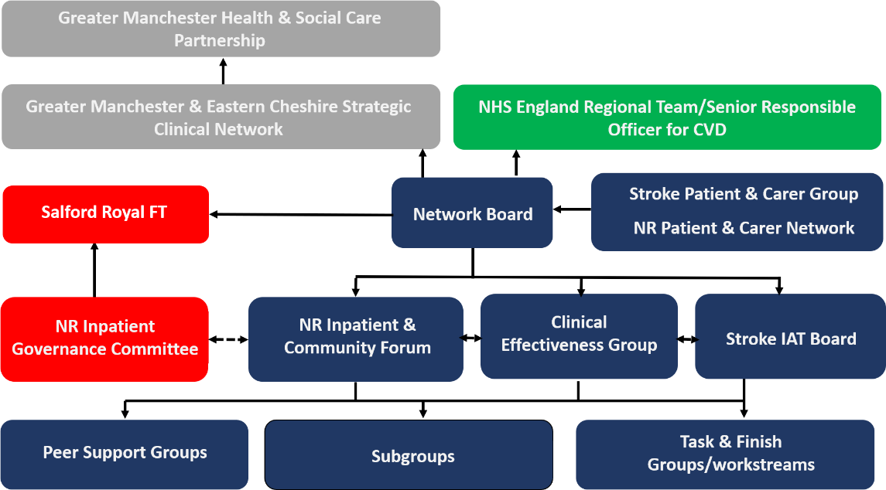

- Membership
The Board will elect two Co-Chairs. One will be professional and the other a patient or carer representative and they will work together to chair the Board, sharing duties as they see fit. The tenure of the Co-Chairs will be two years.
The Board consists of representatives able to authorise plans and commit resources on behalf of their organisations. Collectively they provide clear direction and leadership for GMNISDN team and functions.
Board members are chosen to represent their particular group of organisations on behalf of the patient pathway. Board members have a responsibility to implement Board decisions within their own organisations and to report progress back to the Board.
Each member must identify a nominated deputy of sufficient seniority who shall attend only if the member is unavailable. Details of substitutions must be provided to the GMNISDN Manager in advance of meetings.

Members (34 in total with voting rights)
Two Co-Chairs (1 professional and 1 lay member)
Host organisation senior representative
GMNISDN Clinical Leadership
GMNISDN Manager
One representative from the Comprehensive Stroke Centre, at least Clinical Lead or Directorate Manager level
One representative Acute Stroke Centre, at least Clinical Lead or Directorate Manager level
One representative from two nominated Stroke Recovery Units (SRU), at least Clinical Lead or Directorate Manager level, representatives from other SRUs may attend with speaking rights
NWAS representative
Senior community rehabilitation representatives from each provider of stroke and/or community NR services (i.e. one rep per provider)
Senior representative, Strategic Clinical Network
Two commissioning representatives
Four voluntary sector representatives (2 x stroke & 2 x NR)
Local Authority representative
Mental health representative
Primary care representative
Additional members may be co-opted at times. Quorum will be achieved when at least 40% of Board members or nominees are present at Board meetings, which must include a Chair.

- Meetings
A Co Chair shall preside as chairperson at every Board meeting. No business shall be transacted at any Board meeting unless a quorum of members is present. If quorum is not achieved within fifteen minutes from the time appointed the meeting may proceed but no formal decisions can be agreed as inquorate.
The frequency of meetings will be quarterly. Extraordinary meetings may be added for urgent business related matters.
Administrative support for the meetings will be provided by the GMNISDN. Papers for each meeting will be circulated no less than seven working days prior to the meeting. Formal minutes will be taken and circulated in draft form within 14 working days of each meeting. These minutes will be publicly available upon request, subject to appropriate consideration of any restricted/sensitive items.
There will be no provision of funding for time or travel for members, except travel expenses for lay members will be reimbursed from the GMNISDN budget.

Appendix 1. GMNISDN governance framework
INSERT GOVERNANCE FRAMEWORK WHEN APPROVED

