[](http://intranet.srht.nhs.uk/welcome)

**Not just a funny turn**

Your doctor or health professional thinks you may have had a **TIA**

(**Transient Ischaemic Attack or mini stroke)**

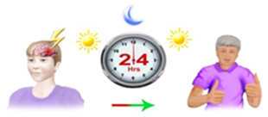

This is a type of stroke that **gets better within 24 hours**

There is more information on page 3

You may have had some of these **symptoms**

|  |  |  |  |  |  |  |  |
| --- | --- | --- | --- | --- | --- | --- | --- |
|  | weak arm or leg | |  | drooping face | |  | strange vision |
|  | | difficulty thinking of words, speaking and understanding other people | | |  | difficulty with your balance | |

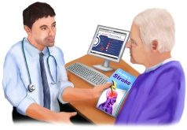

Your doctor or health professional has **referred you to a stroke specialist for tests.**

The specialist will talk about **why**  you had your symptoms,

and how to **reduce your risk** of it happening again

**There are some things you must do now**

|  |  |  |
| --- | --- | --- |
|  | **Take aspirin** if you have been given it  You may be told to take aspirin or another drug if you are **allergic**  to aspirin  You **must** take this until you go to the clinic  **Carry on taking any medicine**  you already take to reduce your risk of heart disease | |
|  | **Do not drive**  at the moment  The specialist will give you advice on driving when you see them | |
|  | **Watch out for symptoms** of a full stroke  There is information to help on page 4 | |
|  | | If your **symptoms do come back**,  or you have other symptoms of a stroke  **call 999 immediately** |
|  | **Go to your appointment**  at the TIA clinic  Without any treatment 1 in 8 people will have a full stroke after their TIA  Ring if you have a question about your appointment at the clinic  0161 206 7209  We are open seven days a week between 9-1pm | |

**What is a Transient Ischaemic Attack?**

**(TIA or mini stroke)**

|  |  |
| --- | --- |
| The **brain**  controls **everything we do -** | |
|  | **movement**  **emotions**  **communication**  **thinking** |
| The **brain needs** **blood**  **Blood**  keeps the **brain working** | |
| C:\Users\SRN\Dropbox\Artwork Stroke\Consent Form Artwork\1 Hospital.jpg | The **blood supply** can **stop**  Then the brain is **damaged**  This can happen **suddenly**  This is called **a stroke** |

For some people the **signs of a stroke go away** within 1 day (24 hours )

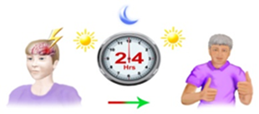

This mini stroke is called a **Transient Ischemic Attack**  or  **TIA**

|  |  |  |
| --- | --- | --- |
| attention%20clipart | | A TIA can be a warning sign of a full stroke |
| So…although your symptoms have gone you need urgent help  You may be **at risk** of a full stroke… even while you are waiting to see the specialist | | |
|  | **Watch out for any symptoms**  Use the FAST test (below) to help  Sometimes there are symptoms that look like stroke but later turn out to be another medical problem  **Ring 999**  and the healthcare experts will decide what to do | |

|  |  |  |  |
| --- | --- | --- | --- |
| The Face, Arm, Speech Test (FAST)  …to help you recognise the symptoms of a stroke | | | |
| **F** | **A** | **S** | **T** |
| **Face weakness** | **Arm weakness** | **Speech problems** | **Time** |
| Can the person smile?  Has their mouth or eye dropped? | Can the person raise both arms equally? | Can the person speak clearly and understand what you say? | **…to call 999** |

For more information go to [www.stroke.org.uk/resources/transient-ischaemic-attack-tia](http://www.stroke.org.uk/resources/transient-ischaemic-attack-tia)

**Produced together with the Greater Manchester Stroke Operational Delivery Network**