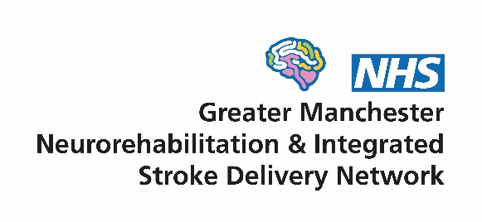

Annual stroke conference poster competition
Our annual stroke conference is on 22nd June 2022 and we will be holding a poster competition to showcase the excellent work of local stroke teams and researchers. There are two categories:
- Pre-hospital and inpatient stroke care
- Community stroke care and longer-term support
Abstracts will be reviewed by the network team and twelve will be asked to present at the conference, with the winners selected by a judging panel on the day. First authors of selected posters will be expected to be available to stand by their poster at some point during the morning/lunch of the conference and speak to the panel.
How to enter
The maximum word count is 370 words. Please avoid using over complicated tables, do not use graphics and use Harvard referencing format. Only one abstract per person as first author. Please indicate which category you wish to enter and include the following headings (or similar):
- Title
- Authors (Harvard format)
- Place of work and address
- Introduction
- Methods
- Results
- Conclusions
The abstract must include sufficient information to allow its evaluation by the judging panel. Expressions such as “data will be presented” or “findings will be discussed” are not acceptable and will result in automatic rejection of the abstract. The onus is on the author to check spelling, grammar and format of the submission.
Please submit your abstract by 22nd April 2022 to sarah.rickard@nca.nhs.uk and successful authors will be informed shortly afterwards.

