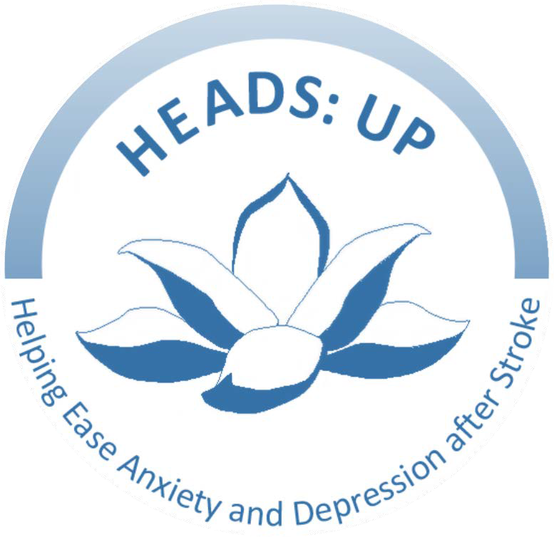

**HEADS: UP**

Helping Ease Anxiety and Depression after Stroke

FINAL REPORT

Plain English version

Spring 2024

# HEADS: UP (Helping Ease Anxiety and Depression after Stroke) Online: results of a randomised controlled trial

## Plain English Report

Authors: Professor Maggie Lawrence1, Dr Bridget Davis1, Ms Naomi Clark1, Dr Graeme Donald2, Professor Nadine Dougall3, Dr Linda Fenocchi1, Professor Helen Mason1

On behalf of the HEADS: UP research collaborators:

Professor Stewart Mercer4, Professor Margaret Maxwell5, Professor Jo Booth1, Mr Nick Croft6, Dr Bhautesh Jani7, Professor Madeleine Grealy8, Dr Eirini Kontou9, Dr Jen MacDonald1 Dr Ben Parkinson1, Ms Matilde Pieri1, Ms. Audrey Taggart4, Dr Suzie Wang10

1Glasgow Caledonian University; 2University of Manchester; 3Edinburgh Napier University; 4University of Edinburgh; 5University of Stirling; 6Lay member; 7University of Glasgow; 8University of Strathclyde; 9University of Nottingham; 10Leeds Beckett University

Spring 2024

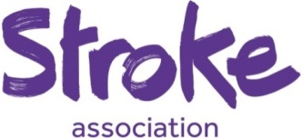 

Table of Contents

1

HEADS: UP (Helping Ease Anxiety and Depression after Stroke) Online: results of a randomised controlled trial 1

Plain English Report 1

SUMMARY 4

Why was the research needed? 4

What questions did we ask? 4

What did we do? 4

What were the results? 5

REPORT 6

Why was this research needed? 6

What questions did we ask in the research? 6

What research did we do? 6

How did we decide which group participants went into? 7

How did we recruit participants? 7

What did participants do? 7

Results 8

What were the results? 8

Were participants happy with the HEADS: UP Online research methods? 9

Did participants fill out all the questionnaires? 9

Did participants take part in the focus groups? 9

Did participants finish the HEADS: UP Online course and practise what they learned? 9

What did we learn about how participants were feeling after 6 months? 9

What did we learn from the HEADS: UP Online research? 10

What next for HEADS: UP? 10

Other HEADS: UP projects 12

HEADS: UP Aphasia 12

Practising Mindfulness after the HEADS: UP Online course has finished 12

HEADS: UP app 12

Taking part in other HEADS: UP research 14

References and Resources 14

Acknowledgements 15

Research Protocol Registration 15

Research Funding 15

# SUMMARY

## Why was the research needed?

Depression and anxiety are common after stroke. As many as a third of stroke survivors may suffer from depression and anxiety for five years or more after having a stroke. At present there is very little available to help people cope better with symptoms. Mindfulness is the practice of being aware of your body, mind, and feelings in the present moment. Mindfulness Based Stress Reduction (MBSR) courses may help people cope better with symptoms of anxiety and depression. We developed an accessible, stroke-specific MBSR course, HEADS: UP (Helping Ease Anxiety and Depression after Stroke).

## What questions did we ask?

1. Were participants happy with the HEADS: UP Online research methods?
2. Did participants finish the HEADS: UP Online course and practise what they learned?

## What did we do?

We recruited adults who had had a stroke at least three months previously, and who had symptoms of depression or anxiety. Participants could take part with a family member. We randomly allocated participants to take part in HEADS: UP Online in the treatment group or the usual care group.

We asked **all the participants** to fill out online questionnaires four times in one year. The questionnaires asked about anxiety and depression, quality of life, and use of health services. We asked **treatment group** participants to do the HEADS: UP Online course (weekly sessions for 9 weeks plus daily practice). We asked **all participants** to take part in focus groups (small discussion groups) after 3 and 6 months. We asked **all participants** about their experience of the research methods. We asked **treatment group** participants what they thought about the course and practicing in their own time.

## What were the results?

Sixty-two people took part, 30 in the treatment group and 32 in the control group. We learned that

* Participants were happy with the research methods.
* Most of the participants who did the course stuck with it and practiced in their own time.
* Several people who did the course gained in confidence and began to ‘do more’.
* HEADS: UP Online may help people who have had a stroke feel less anxious and less depressed. This now needs to be fully tested in a large-scale randomised controlled trial.

# REPORT

## Why was this research needed?

A third of stroke survivors may suffer from depression and anxiety in the long-term after stroke. At present there is very little available to help them cope better with symptoms.

[Mindfulness](https://dictionary.cambridge.org/dictionary/english/mindfulness) is the practice of being aware of your body, mind, and feelings in the present moment. It is a practice that is growing in popularity. Mindfulness Based Stress Reduction (MBSR) courses use meditation techniques such as breathing exercises and gentle movement to help people cope with symptoms of anxiety and depression. MBSR courses also teach people important self-care habits – such as encouraging people to be compassionate towards themselves and others. Although people find MBSR helpful, they often struggle to follow the whole 8-week course. After a stroke, sticking with an MBSR course can be difficult for reasons including fatigue, poor memory, and transport difficulties.

In 2018 the HEADS: UP research team worked with people who had had a stroke and family members to make the MBSR course easier to follow. Together we developed a stroke-specific course, HEADS: UP (Helping Ease Anxiety and Depression after Stroke). The course runs weekly for 9 weeks. Most of the sessions are 2.5 hours long, with two 15-minute breaks. We hoped that the new course might be easier to follow. The next step was to ask people who had had a stroke, and their family members, to take part in research to test out HEADS: UP.

## What questions did we ask in the research?

We asked two questions:

1. Were participants happy with the HEADS: UP Online research methods?
2. Did participants finish the HEADS: UP Online course and practise what they learned?

## What research did we do?

To answer the two research questions, we did a pilot Randomised Controlled Trial (RCT).

An RCT allows researchers to put people into two different groups and compare them. One group is the **treatment group,** and one group continues as usual (the **control group**). This is important when we do not know if taking part in a treatment group will have better results for people. Having two separate groups lets us see if the treatment is helpful or if any changes people tell us about would have happened anyway.

## How did we decide which group participants went into?

When participants signed up to the research, we gave them an ID number. A computer that had no information about participants except for their ID numbers, randomly put the ID numbers into one of two groups. In other words, participants were put into either the treatment group or the control group **by chance**. We call this randomisation.

When this had been done, the research team phoned participants to let them know which group they were in.

## How did we recruit participants?

We worked with stroke organisations and charities such as the Stroke Association and Chest, Heart and Stroke Scotland to recruit research participants. We also posted on social media, including Twitter (now X) and Facebook. We aimed to recruit 60 adults who had had a stroke at least three months previously, and who had at least mild symptoms of depression or anxiety. Participants could take part on their own or with a family member or friend, if they liked.

## What did participants do?

We asked **all participants** to fill out questionnaires about anxiety and depression, quality of life, and their use of health services. The questionnaires were online. We posted paper copies to participants who preferred to fill them out by hand. We asked participants to fill out the questionnaires four times in one year.

We asked participants in the **treatment group** to do the 9-week HEADS: UP Online course.

We asked **all participants** to take part in focus groups. In this study, the focus groups were small groups of participants who came together, with researchers, to discuss their opinions and experiences. One focus group was after 3 months. The second one was after 6 months. In the focus groups we asked **all participants** what they thought about the research methods. We asked participants in the **treatment group** what they thought about the HEADS: UP course and practicing in their own time. Some people needed help getting online, especially at first. We provided guidance and support, if needed.

# Results

## What were the results?

We recruited 64 people. Two dropped out after they had signed up. After randomisation, 30 people were in the treatment group (HEADS: UP) and 32 in the control group.

Treatment group participants were 56 years of age (average). Control group participants were 57 years old (average). More women took part than men. Almost everyone who took part described themselves as White. Most people had been to college or university. Most participants lived with someone. Most participants were retired or on long-term sick leave. Fourteen people took part with another family member – usually their husband or wife.

More detail is given in Table 1.

Table 1: The participants

|  |  |  |
| --- | --- | --- |
|  | **Treatment**  **(30 participants)** | **Control**  **(32 participants)** |
| **Age (average)** | 56 years | 57 years |
| **Gender** | Female 70% | Female 45% |
| **Time since stroke (average)** | 15 months | 24 months |
| **Living arrangements** | With other(s) 73% | With other(s) 72% |
| **Ethnicity (White)** | 93% | 94% |
| **Employed** | 20% | 34% |
| **Education (University)** | 50% | 38% |
| **Took part with a family member** | 23% | 24% |
| **Recruitment route** | Stroke Association 43%  Social media 40% | Stroke Association 28%  Social media 63% |

## Were participants happy with the HEADS: UP Online research methods?

### Did participants fill out all the questionnaires?

Most participants (80%) were able to fill out the questionnaires on their own. Some asked for help from their families or from the research team.

Thirteen participants did not fill out the questionnaires every time we asked – they ‘dropped out’ of the research before it ended. There were lots of reasons. Some participants were too busy. Some had health problems. We lost contact with some people.

Twenty-four (92%) participants in the treatment group filled out at least one weekly log about their mindfulness practice. One participant said: *I found it very straight forward to complete the log on my own so wouldn't suggest any change (ID: 86)*

### Did participants take part in the focus groups?

Thirty-nine people took part in focus groups after the course had finished, three months into the research. Twenty-two people took part after six months.

## Did participants finish the HEADS: UP Online course and practise what they learned?

Four people (13%) in the treatment group dropped out after they had answered the questionnaires but before the course started. Once the course started, most people stuck with it. Twenty-four participants (92%) attended at least four of the weekly sessions. Fourteen people (54%) attended 8 sessions. Participants practiced what they learned each week. Most people practiced for about 23 minutes a day, 6 days a week. For some people finding time to practice was difficult. One person said: *At the beginning I did really struggle to put [mindfulness] into my daily life and commit to it but having reinforcement from everybody else [in the group] every week helped.*

## What did we learn about how participants were feeling after 6 months?

Information from the **questionnaires** told us that **most participants** **felt less anxious and less** depressed by the time the research came to an end. **On average, people in the treatment group had improved more than the people in the control group.**

In the **focus groups** some participants in the **treatment group** told us they had noticed that their **relationships with family members and friends had improved**. Many participants in the treatment group told us they felt more confident since doing the course. Because they felt more confident, participants took on more challenges. For example, some participants had gone back to work. Others had returned to pastimes they had enjoyed before they had had a stroke. This included going back to different activities such as swimming or choir and being out and about more. A few participants signed up for different courses. Two were training to be mindfulness trainers. One participant was training to be a counsellor. This is what participants said: *HEADS: UP has provided me with the confidence to live positively.*

Participants in the **control group** told us that they still felt in a low mood. They lacked confidence and motivation. They were not taking on new challenges. Some participants in the control group were worried about their health. One person said: *I have not got my confidence back … medics look at the physical, they don’t look at the emotional.* Some participants had tried to do mindfulness using online apps and websites. Most found this difficult - partly because there was too much choice!

## What did we learn from the HEADS: UP Online research?

* The research methods ‘worked’ - and participants were happy with them.
* Most of the treatment group stuck with the course and practiced in their own time.
* People in the treatment group often gained in confidence and went on to ‘do more’.
* HEADS: UP Online may help people who have had a stroke feel less anxious and less depressed than if they did not do the course.

## What next for HEADS: UP?

We will

* Share the research findings, widely
* Talk to organisations that fund stroke research
* Apply for funding for a bigger research study to test HEADS: UP with 100s of participants to find out if it really does work for people who have had a stroke. If it does – it could become an essential part of stroke rehabilitation in the future.

## Other HEADS: UP projects

### HEADS: UP Aphasia

People with aphasia after stroke may not think that the HEADS: UP Online course is easy to do. Matilde Pieri, a Speech and Language Therapist, has been working with people with aphasia to create an aphasia-friendly version called **HEADS: UP Aphasia.** Working together with people with aphasia, Matilde has created content for the HEADS: UP Aphasia course as part of her PhD research. Matilde is writing up her research at the moment. Once this has been done, she will be able to develop the full course.

If you would like to find out more about this work, you can

Email: [Matilde.Pieri@gcu.ac.uk](mailto:Matilde.Pieri@gcu.ac.uk)

### Practising Mindfulness after the HEADS: UP Online course has finished

After finishing a HEADS: UP Online course many participants told us that keeping up their mindfulness practice in the long-term was sometimes difficult. Naomi Clark, a psychology graduate and former HEADS: UP research assistant, is studying for a PhD about long-term mindfulness practice. Naomi's research involves working with people affected by stroke to learn more about what makes long-term mindfulness practice difficult and what could help to make it easier. If you would like to find out more about this work, you can

Email: [Naomi.Clark@gcu.ac.uk](mailto:Naomi.Clark@gcu.ac.uk)

Phone: 0141 331 3107

### HEADS: UP app

Dr Ben Parkinson, a mental health nurse and lecturer, is planning to develop a HEADS: UP app. The HEADS: UP app will allow people who find it difficult to attend weekly classes to learn mindfulness at a time that best suits them. The app will also help people to continue with their mindfulness practice after they have finished a HEADS: UP course.

If you would like to find out more about this work, you can

Email: Ben.Parkinson@gcu.c.uk

Phone: 0141 331 3114

## Taking part in other HEADS: UP research

If you are interested in taking part in any future HEADS: UP research or any of the research studies mentioned on page 10, please get in touch! We’d be happy to hear from you.

Email: [headsup@gcu.ac.uk](mailto:headsup@gcu.ac.uk)

Phone: 0141 331 3421

# References and Resources

A formal **paper** reporting how HEADS: UP was developed is available, free to download, from: <https://doi.org/10.3390/healthcare11030355>

You can watch short **videos** made by some of the HEADS: UP research participants on the HEADS: UP YouTube channel**: http://youtube.com/@headsup6765**

You can Follow HEADS: UP on X (Twitter) **@StrokePathways** and **@HeadsUpStroke**

# Acknowledgements

The authors acknowledge the help and support they received from individuals and organisations including, but not limited to

Administrators of the Facebook groups: Stroke Rehabilitation, Stroke Recovery UK

Chest, Heart and Stroke, Scotland

HEADS: UP followers on social media, too numerous to mention

HEADS: UP Project Advisory Group: Mrs Betty Gilmour, Mr Colin Fraser, Mr George and Mrs Anne Melville, Mrs Audrey Taggart

HEADS: UP Trial Advisory Group: Professor Martin Dennis, Dr Richard Francis, Professor Fiona Jones, Mr Mark Cadman, Dr Liz Cunningham

Mindfulness trainers: Kristine Jensen and Carol Ann Ramsay. And Chloe Homewood, trainer, friend and enthusiastic HEADS: UP supporter – we miss you.

Network contacts including clinicians, third sector representatives, researchers, and mindfulness based stress reduction trainers from across the UK and beyond

and last but not least, our funders the Stroke Association who have supported us throughout

We are very grateful to you all for your continued support and commitment.

## Research Protocol Registration

ClinicalTrials.gov: NCT04985838

Available from: https://clinicaltrials.gov/study/NCT049858383

## Research Funding

Stroke Association SA PPA 18\100011

https://www.stroke.org.uk/eHh