**Neurorehabilitation Inpatient & Community Forum**

**Terms of Reference**

1. **Context**

The Greater Manchester Neurorehabilitation & Integrated Stroke Delivery Network (GMNISDN) was launched in October 2021 following the merger of the region’s neurorehabilitation and stroke network. The organisation is a partnership of NHS Trusts stroke and neurorehabilitation services in the Greater Manchester region, including Eastern Cheshire as well as the North West Ambulance Service. The network works closely with other stakeholders including the voluntary sector, academia and commercial organisations. The network supports the whole care pathway for stroke whilst focusing only on community care for neurorehabilitation patients. It is a non-statutory body hosted by the Northern Care Alliance Foundation Trust.

1. **Vision**

Supporting the development of high quality and equitable stroke and community NR services, to achieve the best outcomes and experience for patients. We will do this by:

* Being patient centred
* Working collaboratively with our stakeholders
* Facilitating transformational change through effective partnership working
* Encouraging the early adoption of evidence and innovation in our services

1. **Role of the Neurorehabilitation Inpatient & Community Forum**

Following the transition to a single provider model for inpatient NR services, the pathway is now split in terms of governance, with the community element retained within GMNISDN and the inpatient pathway overseen by the single provider (which will be Northern Care Alliance NHS FT). The Forum will help ensure there is a cohesive approach to development and delivery of the whole NR care pathway in GM.

The meeting will focus predominantly on issues that impact the whole pathway i.e. inpatient and community. Community only elements will be primarily discussed within the network’s Community Neurorehabilitation Forum.

The Forum will provide an opportunity for stakeholders to discuss in detail aspects relating to operational delivery, service improvement, performance management, clinical effectiveness and governance. The network’s Clinical Effectiveness Group (CEG) will remain responsible for the oversight of performance management, clinical effectiveness and governance and will approve key decisions and documents developed within the Forum.

The Forum will be dependent on good engagement with providers who deliver NR services in an inpatient and also outpatient setting, as well as in the community. Other stakeholders will include specialties such as neurology, neurosurgery and spinal surgery who also refer their patients into community NR services.

The group will:

* Work to collaboratively develop and maintain a robust patient-centred NR pathway in GM
* Provide pathway/team updates as part of operational discussions to identify current statuses, key issues and areas of best practice within the whole-pathway
* Review and address pathway issues to ensure delivery of the highest quality services in terms of patient outcomes and experience. Issues may need escalation to the wider GM stakeholders and/or the network’s CEG and/or Board
* Support identification of clinical priorities for the NR pathway, including the setting of bespoke clinical standards/protocols (with approval via the CEG) and supporting their implementation
* Support the implementation of any nationally set priorities and standards
* Support monitor of the whole-pathway services performance, including the delivery of the whole-pathway service transformation benefits, feeding into the CEG when appropriate.
* Develop and implement service improvement strategies of benefit to the whole NR pathway
* Develop plans to achieve consistency of services, quality and best outcomes for patients of benefit to the whole NR pathway
* Identify potential training needs and opportunities to be fed into the network’s Workforce Development Subgroup
* Facilitate and promote the sharing of operational best practice as well as partnership working between provider organisations and other stakeholders

1. **Governance arrangements**

The NR Inpatient and Community Forum reports directly to the Clinical Effectiveness Group

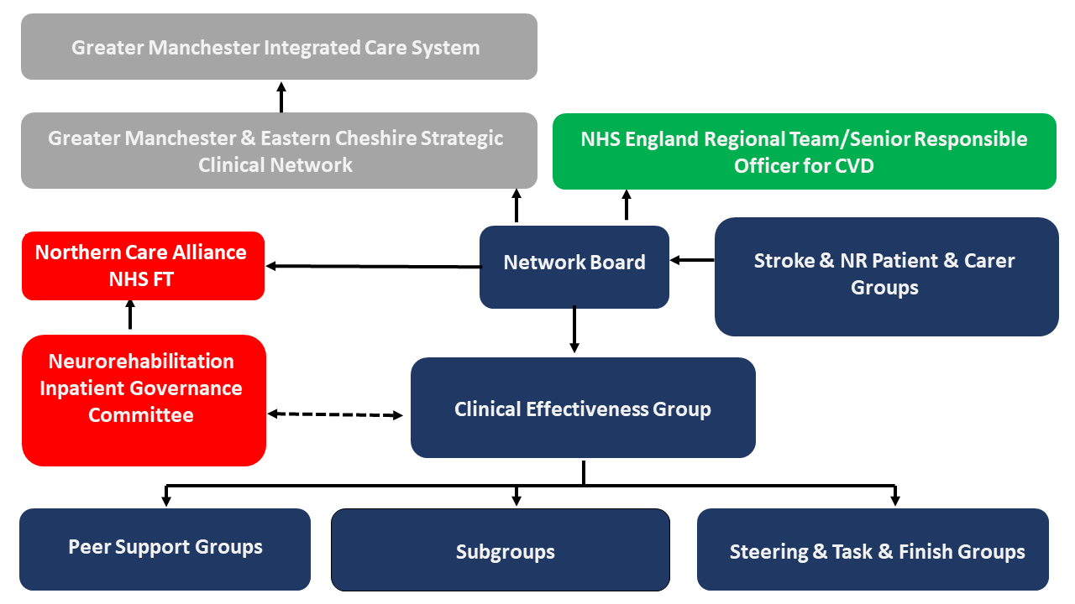

1. **Membership**

The Forum will be co-chaired by the Salford Royal FT Clinical Director for inpatient NR services and GMNISDN Clinical Lead. Members are chosen to represent their particular group of organisations on behalf of the patient pathway. Members have a responsibility to implement Forum decisions within their own organisations and to report progress back to the Forum.

Each member must identify a nominated deputy of sufficient seniority who shall attend only if the member is unavailable. Details of substitutions must be provided to the GMNISDN Manager in advance of meetings.

All members are required to abide by the network’s code of conduct for attendance at meetings (appendix 1)

***Members***

GMNISDN Clinical Leadership

GMNISDN Manager and Facilitator

Salford Royal FT Clinical Director for inpatient NR services

NHS England neurorehabilitation Case Manager

Clinical and/or managerial representative from each community NR service

Clinical representation from inpatient NR services to include, but not limited to, Lead Nurse and Consultant AHP

Inpatient NR Senior Manager

NR Complex Discharge Team

Voluntary sector representatives

Additional members may be co-opted.

1. **Meetings**

The Forum will meet quarterly. No business shall be transacted at any Forum meeting unless a quorum of 40% of members is present. If quorum is not achieved within fifteen minutes from the time appointed for a meeting, the meeting shall stand adjourned. If quorum is not achieved within fifteen minutes from the time appointed the meeting may proceed but no formal decisions can be agreed as inquorate.

Administrative support for the meetings will be provided by the GMNISDN. Papers for each meeting will be circulated no less than seven working days prior to the meeting. Formal minutes will be taken and circulated in draft form within 14 working days of each meeting. These minutes will be publicly available upon request, subject to appropriate consideration of any restricted/sensitive items. There will be no provision of funding for time or travel for members.

**Appendix 1. GMNISDN code of conduct for attendance at meetings**

