**Stroke Inpatient & Community Forum**

**Terms of Reference**

1. **Context**

The Greater Manchester Neurorehabilitation & Integrated Stroke Delivery Network (GMNISDN) was launched in October 2021 following the merger of the region’s neurorehabilitation and stroke network. The organisation is a partnership of NHS Trusts stroke and neurorehabilitation services in the Greater Manchester region, including Eastern Cheshire as well as the North West Ambulance Service. The network works closely with other stakeholders including the voluntary sector, academia and commercial organisations. The network supports the whole care pathway for stroke whilst focusing only on community care for neurorehabilitation patients. It is a non-statutory body hosted by the Northern Care Alliance Foundation Trust.

1. **Vision**

Supporting the development of high quality and equitable stroke and community NR services, to achieve the best outcomes and experience for patients. We will do this by:

* Being patient centred
* Working collaboratively with our stakeholders
* Facilitating transformational change through effective partnership working
* Encouraging the early adoption of evidence and innovation in our services

1. **Role of the Stroke Inpatient & Community Forum**

The Forum will be responsible for supporting the continued development of high-quality stroke services. It will help ensure there is a cohesive approach to development and delivery of the stroke care pathway in GM so that inpatient and community services have a platform where they can be discussed together. The meeting will focus predominantly on the acute, inpatient rehabilitation, community and life after stroke elements of the pathway, with hyper acute issues the responsibility of the network’s Hyper Acute Stroke Unit (HASU) Forum, and cardiovascular disease (CVD) prevention under the auspices of the network’s CVD Prevention Subgroup.

The Forum will provide an opportunity for stakeholders to discuss in detail aspects relating to operational delivery, service improvement, performance management, clinical effectiveness and governance. The network’s Clinical Effectiveness Group (CEG) will remain responsible for the oversight of performance management, clinical effectiveness and governance and will approve key decisions and documents developed within the Forum.

The Forum will be dependent on good engagement with providers who deliver stroke services in an inpatient setting, as well as in the community. Other stakeholders will include voluntary sector organisations that support stroke patients and social care.

The group will:

* Work to collaboratively develop and maintain a robust patient-centred stroke pathway in GM - focusing on acute, inpatient rehabilitation, community and life after stroke
* Provide pathway/team updates as part of operational discussions to identify current statuses, key issues and areas of best practice
* Review and address pathway issues to ensure delivery of the highest quality services in terms of patient outcomes and experience. Issues may need escalation to the wider GM stakeholders and/or the network’s CEG and/or Board
* Support identification of clinical priorities for the stroke pathway, including the setting of bespoke clinical standards/protocols (with approval via the CEG) and supporting their implementation
* Support the implementation of any nationally set priorities and standards
* Support monitoring of services performance, including the analysis of regional and national SSNAP data and feeding into the CEG when appropriate.
* Develop and implement service improvement strategies
* Develop plans to achieve consistency of services, quality and best outcomes for patients
* Identify potential training needs and opportunities to be fed into the network’s Workforce Development Subgroup
* Facilitate and promote the sharing of operational best practice as well as partnership working between provider organisations and other stakeholders
* Receive and discuss stroke related updates from other network meetings including the HASU Forum, CVD Prevention and Rehabilitation Subgroup and facilitate wider discussion where there is overlap

1. **Governance arrangements**

The Stroke Inpatient and Community Forum reports directly to the Clinical Effectiveness Group

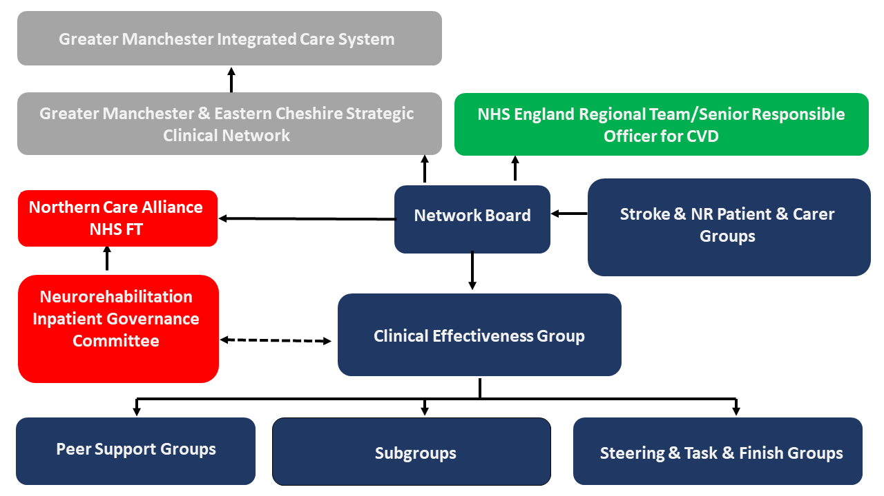

1. **Membership**

The Forum will be chaired and co-chaired by the GMNISDN Clinical Leads representing stroke services. Members are chosen to represent their particular group of organisations on behalf of the patient pathway. Members have a responsibility to implement Forum decisions within their own organisations and to report progress back to the Forum.

Each member must identify a nominated deputy of sufficient seniority who shall attend only if the member is unavailable. Details of substitutions must be provided to the GMNISDN Team in advance of meetings.

All members are required to abide by the network’s code of conduct for attendance at meetings (appendix 1)

***Members***

GMNISDN Clinical Leadership

GMNISDN Manager and Facilitator

Clinical and/or managerial representative from each community stroke service

Clinical and/or managerial representation from each inpatient stroke service

Voluntary sector representatives

Social care representative

Additional members may be co-opted.

1. **Meetings**

The Forum will meet quarterly. No business shall be transacted at any Forum meeting unless a quorum of 40% of members is present. If quorum is not achieved within fifteen minutes from the time appointed the meeting may proceed but no formal decisions can be agreed as inquorate.

Administrative support for the meetings will be provided by the GMNISDN. Papers for each meeting will be circulated no less than seven working days prior to the meeting. Formal minutes will be taken and circulated in draft form within 14 working days of each meeting. These minutes will be publicly available upon request, subject to appropriate consideration of any restricted/sensitive items. There will be no provision of funding for time or travel for members.

**Appendix 1. GMNISDN code of conduct for attendance at meetings**

