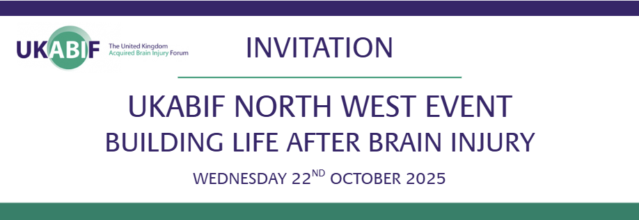

We are delighted to invite you to the upcoming UKABIF North West Networking event.

Event Details
Date: Wednesday 22nd October 2025
Location: The Walton Centre, Lower Ln, Fazakerley, Liverpool L9 7LJ
Meeting Room: 2nd Floor Lecture Theatre (Sid Watkins Building)
Timings:
14:30 Arrival & Refreshments
15:00 Presentation
16:00 Networking
16:30 Close

This important event will bring together professionals, advocates, and individuals with lived experience to explore new and effective ways to support people affected by brain injury across the UK. The session will deliver education, insight, and practical tools to help raise awareness and share knowledge across communities and services.

Speakers Include:
• Gerard Martin, Kings Counsel – Chair of UKABIF North West
Opening remarks and update on UKABIF National, future plans, and upcoming events.
• Phillip Barr – Development Officer, Headway Wirral & Former Superintendent, Merseyside Police
Exploring support available beyond the NHS and the role of organisations such as Headway.
• Amanda Lewis – Brain Injury Survivor
Sharing lived experience and how activities have helped to achieve positive outcomes.
• Colin Green – Specialist Neurological Physiotherapist, Physio Matters
Discussing the importance of rehabilitation and adapting to a new normal.

Please RSVP to ukabifnw@gmail.com by 9th October 2025

We look forward to welcoming you to an inspiring and informative afternoon.

Kind regards,
UKABIF North West

