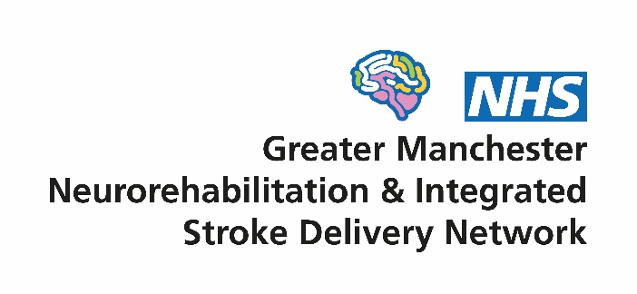
Oversight Group
Terms of Reference

- Context
The Greater Manchester Neurorehabilitation & Integrated Stroke Delivery Network (GMNISDN) was launched in October 2021 following the merger of the region’s neurorehabilitation and stroke networks. It is a partnership of NHS Trusts providing stroke and neurorehabilitation services in Greater Manchester and Eastern Cheshire, as well as the North West Ambulance Service (NWAS). It is a non-statutory body hosted by the Northern Care Alliance NHS Foundation Trust (NCA) that reports to the Greater Manchester Integrated Care Board (ICB).
The network works closely with other stakeholders including the voluntary sector, academia and commercial organisations. It supports the whole care pathway for stroke and focuses on community care for neurorehabilitation.

- Vision
The network supports the development of high quality and equitable stroke and community neurorehabilitation services, to achieve the best outcomes and experience for patients. It does this by:
- Being patient centred
- Working collaboratively with our stakeholders
- Facilitating transformational change through effective partnership working
- Encouraging the early adoption of evidence and innovation in our services

- Purpose of the network
The GMNISDN brings key stakeholders together to facilitate a collaborative approach to improving the region’s stroke and community neurorehabilitation services. Its approach is patient centred, evidenced based and aligns with the ambitions of the NHS 10 Year Health Plan for England.
The achieve this, the network will:
- Provide impartial expert clinical leadership and project support
- Help develop and implement strategic improvements to local clinical pathways
- Optimise patient flow and care pathways to enhance outcomes and use NHS resources effectively
- Work with system partners to manage capacity and demand
- Support the transition to a single provider model for inpatient neurorehabilitation and promote collaboration across the whole care pathway
- Drive data-led improvement, including engagement with Sentinel Stroke National Audit Programme (SSNAP) and other data collection/audits.
- Horizon scan to future-proof services and support delivery of the NHS Long Term Plan and its three left shifts

- Role of the Oversight Group
The Group provides strategic direction, governance, and accountability for the network. It oversees the development and implementation of network strategies, plans and activities to ensure the organisation delivers its objectives and fulfils its purpose. The Group is responsible for service improvement, performance management, clinical effectiveness and governance.
This will include:
- Supporting a culture of collaborative, partnership working and effective communication between Greater Manchester stroke and community neurorehabilitation NHS providers, the wider healthcare system (including the ICB) and other stakeholders e.g. voluntary sector, academia, Health Innovation Manchester
- Ensuring a patient centred approach to improvement of services through meaningful involving people with lived experience (e.g. via network’s Patient and Carer Group) as well as encouraging engagement with the voluntary sector
- Agreeing an annual work plan and supporting the network team in its delivery
- Monitoring progress of the network by regularly reviewing performance and reporting to the ICB, NHS England Regional Team (or its successor) and other bodies as required
- Supporting the Greater Manchester healthcare system to develop and implement local clinical pathways in line with the national stroke model and other relevant national/local guidelines, policies, best practice or evidence
- Encouraging compliance and utilisation of audit information and research evidence to enhance service improvement work in individual provider organisations
- Supporting and approving the development of appropriate local standards/protocols/pathways and overseeing their implementation
- Leading on the clinical effectiveness and governance of the Greater Manchester stroke and community neurorehabilitation pathways
- Regularly reviewing relevant information and data (including SSNAP audit) and advising on necessary actions including undertaking audits
- Reviewing reported incidents and complaints at a strategic level and identifying and acting upon trends and serious concerns
- Reviewing and mitigating risks to network business and delivery of local services
- Providing clear direction and oversight of each subgroup that reports to the Oversight Group
- Providing a forum to raise and address concerns relating to service quality, delivery, capacity and outcomes
- Holding Greater Manchester NHS provider organisations to account in implementing Oversight Group decisions

- Governance arrangements
In October 2025, the network merged its Board and Clinical Effectiveness Group (CEG) into a single Oversight Group. Previously, the CEG reported to the Board, which in turn was directly accountable to the ICB’s Long-Term Conditions/Secondary Prevention Group and considered a programme within the local Greater Manchester & Eastern Cheshire Strategic Clinical Network (like cardiac, diabetes etc).
The network’s governance structure is now as follows:
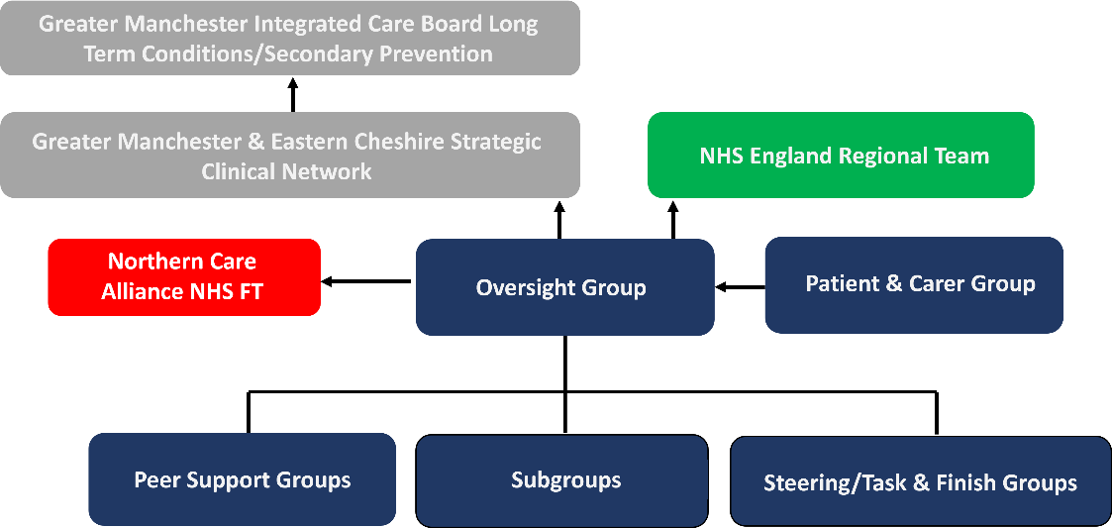
The Oversight Group will continue to be accountable to the Long-Term Conditions/Secondary Prevention Group or its successor whilst changes to the ICB role and governance are finalised as part of wider NHS system reconfiguration in 2025/26.
The network is also accountable to its host organisation, the NCA, which hosts the network on behalf of all Greater Manchester stroke and neurorehabilitation NHS providers.
Following rationalisation of network groups in October 2025, its Patient and Carer Group, Subgroups, Steering/Workstream Groups and Task and Finish Groups now report directly to the Oversight Group.

- Host organisation
The network is not a separate legal entity but operates via a formal agreement with its Host, the NCA. The network reports to the NCA Hosted Services Board on a regular basis. The NCA, as host, is a member of the Oversight Group in addition to any other role that may entitle the organisation to attend.
The obligations and responsibilities of the Host and network are set out in a formal service agreement which includes detail on:
- Employment of network core staff
- Premises for the core team
- Finance, IT, HR and facilities support
- Insurance and indemnity arrangements
- Dispute resolution
- Access to training facilities
Provision will be made in the network budget to cover an annual hosting fee.

- Membership
Oversight Group membership shall be comprised of representative roles coupled with the expertise required to fulfil its objectives. Active consideration will be given to diversity and equality amongst members.
The Oversight Group will elect two Co-Chairs. One will be an NHS professional and the other a patient or carer representative/advocate (e.g. voluntary sector organisation) and they will work together to chair the Group, sharing responsibilities according to their expertise. The tenure of the Co-Chairs will be two years.
The Oversight Group consists of representatives able to authorise plans and commit resources on behalf of their organisations. Collectively they provide clear direction and leadership for network team and functions.
Members have a responsibility to implement Oversight Group decisions within their own organisations and report progress back.
Each member must identify a nominated deputy of sufficient seniority who shall attend only if they are unavailable.
All members are required to abide by the network’s code of conduct for meetings (appendix 1). Members must also adhere to the Greater Manchester NHS Conflicts of Interest Policy and will be asked to declare any at the start of each meeting.

Members
Two elected Co-Chairs
Host organisation senior representative
GMNISDN Clinical Leadership
GMNISDN Manager
A representative from each Greater Manchester stroke unit (Clinical Lead/Director or Senior Manager)
Senior NCA inpatient neurorehabilitation representative
Senior NWAS representative
Senior representative from each Greater Manchester community stroke/neurorehabilitation service (Team Lead or above)
Greater Manchester & Eastern Cheshire Strategic Clinical Network Director
Senior ICB representative
Patient & Carer Group Chairs
Four voluntary sector representatives (2 x stroke & 2 x neurorehabilitation)
Additional members may be co-opted, especially following clarification of the role and governance of the ICB and its constituent parts and taking into account wider NHS system changes. Quorum will be achieved when at least 40% of members or nominees are present, which must include a Chair.

- Meetings
A Co Chair shall preside as chairperson at every meeting. No business shall be transacted at any Oversight Group meeting unless a quorum of members is present. If quorum is not achieved within 15 minutes from the time appointed the meeting may proceed but no formal decisions can be agreed as inquorate.
The frequency of meetings will be quarterly. Extraordinary meetings may be added for urgent business-related matters.
Administrative support for the meetings will be provided by the network. Papers for each meeting will be circulated no less than 7 working days prior to the meeting. Formal minutes will be taken and circulated in draft form within 14 working days of each meeting. These minutes will be publicly available upon request, subject to appropriate consideration of any restricted/sensitive items.
The network is committed to being open and transparent in decision making. Recording of discussions will take place to aid the production of minutes using AI.
There will be no provision of funding for members to attend.

Appendix 1. GMNISDN code of conduct for attendance at meetings

