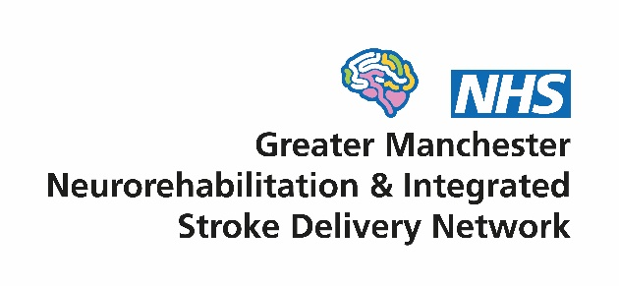

**Clinical Effectiveness Group**

**Terms of Reference**

1. **Context**

Since 2015, there have been two networks in Greater Manchester (GM) overseeing service improvement of the local neuro-rehabilitation (NR) and stroke pathways - the GM Neuro-rehabilitation Network (NRN) and the GM Integrated Stroke Delivery Network (ISDN). The significant overlap of the work programmes of two networks coupled with a funding shortfall in the NRN budget led to a decision at both network Boards in mid 2021 to merge the organisations into a single structure. The merged network will be called the GM Neuro Rehabilitation & Integrated Stroke Delivery Network (GMNISDN) and formally commenced on 1st October 2021.

1. **Vision**

Supporting the development of high quality and equitable stroke and community NR services, to achieve the best outcomes and experience for patients. We will do this by:

* Being patient centred
* Working collaboratively with our stakeholders
* Facilitating transformational change through effective partnership working
* Encouraging the early adoption of evidence and innovation in our services

1. **Role of the Clinical Effectiveness Group**

The Clinical Effectiveness Group (CEG) will help deliver the vision and objectives of the GMNISDN. The CEG will be responsible for supporting the continued development of high-quality stroke and community NR services and will focus on overseeing aspects relating to service improvement, performance management, clinical effectiveness and governance. The CEG will:

* Facilitate and promote the sharing of best practice and partnership working between provider organisations and other stakeholders, including patients and carers
* Support the development of high quality, person-centred care pathways that meet the national stroke service specification and other relevant national standards/guidelines for NR and stroke and deliver the highest quality in terms of patient outcomes and experience
* Develop and oversee service improvement activities using appropriate information to help inform and prioritise a programme of work
* Encourage compliance and utilisation of audit information and research evidence to enhance service improvement work in individual provider organisations
* Support and approve the development of appropriate local standards/protocols/pathways and oversee their implementation
* Lead on the clinical effectiveness and governance of the Greater Manchester stroke and community NR pathways including:
  + Ensuring robust processes are in place
  + Regularly reviewing relevant information and data (including SSNAP audit) and advising on necessary actions including undertaking audits
  + Review of reported incidents and complaints at a strategic level and identifying and acting upon trends and serious concerns
* Instigate task and finish groups to undertake specific pieces of time limited work
* Involve patients and carers wherever possible and adopt a patient centred approach

1. **Governance arrangements**

The CEG operates within the GMNISDN Governance Framework (appendix 1) and reports directly to the GMNISDN Board with a number of Subgroups (Sector Forums, Training and Education and Rehabilitation) and Task and Finish Groups reporting to the CEG.

1. **Membership**

The CEG will be chaired by a GMNISDN Clinical Co-Director or the GMNISDN Manager if neither are available.

Members are chosen to represent their particular group of organisations on behalf of the patient pathway. Members have a responsibility to implement CEG decisions within their own organisations and to report progress back to the CEG.

Each member must identify a nominated deputy of sufficient seniority who shall attend only if the member is unavailable. Details of substitutions must be provided to the GMNISDN Manager in advance of meetings.

All members are required to abide by the network’s code of conduct for attendance at meetings (appendix 2).

***Members***

GMNISDN Clinical Leadership

GMNISDN Manager & Facilitators

Acute Stroke Centre representatives (Senior Manager and/or Clinical Lead)

Stroke Recovery Unit representatives (Senior Manager and/or Clinical Lead)

Inpatient NR representative

Co-Chairs of Rehabilitation Subgroup

Co-Chairs of Training & Education Subgroup

Voluntary sector organisation representatives (2 x stroke and 2 x NR)

Community rehabilitation representatives from each provider of stroke and NR services

2 CCG representatives

Clinical Research Network: Greater Manchester Stroke Lead

Additional members may be co-opted. Quorum will be achieved when at least 40% of CEG members or nominees are present.

1. **Meetings**

The CEG will meet bi-monthly. No business shall be transacted at any CEG meeting unless a quorum of 40% of members is present. If quorum is not achieved within fifteen minutes from the time appointed for a CEG meeting, the meeting shall stand adjourned. If quorum is not achieved within fifteen minutes from the time appointed the meeting may proceed but no formal decisions can be agreed as inquorate.

Administrative support for the meetings will be provided by the GMNISDN. Papers for each meeting will be circulated no less than seven working days prior to the meeting. Formal minutes will be taken and circulated in draft form within 14 working days of each meeting. These minutes will be publicly available upon request, subject to appropriate consideration of any restricted/sensitive items. There will be no provision of funding for time or travel for members.

**Appendix 1. GMNISDN governance framework**



**Appendix 2. GMNISDN code of conduct for attendance at meetings**

