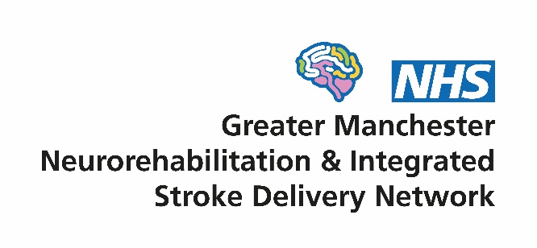

Intra-arterial Thrombectomy Board
Terms of Reference

- Context
Since 2015, there have been two networks in Greater Manchester (GM) overseeing service improvement of the local neuro-rehabilitation (NR) and stroke pathways - the GM Neuro-rehabilitation Network and the GM Integrated Stroke Delivery Network. The significant overlap of the work programmes of two networks coupled with a funding shortfall in the NRN budget led to a decision at both network Boards in mid 2021 to merge the organisations into a single structure. The merged network will be called the GM Neuro Rehabilitation & Integrated Stroke Delivery Network (GMNISDN) and formally commenced on 1st October 2021.
The IAT Board was initially convened in 2017 as part of the stroke network to establish a robust regional service for Intra Arterial Thrombectomy (IAT) in compliance with NHSE commissioning requirements. IAT is now contained as a specific element within the new national service model for stroke (appendix 1, page 19) and its delivery in GM will be monitored through the national stroke programme as well as NHSE regional structures.
The group has always provided the necessary expertise to help collaborative develop and oversee implementation of the service for Greater Manchester residents, based on the existing centralised acute stroke pathway. It has achieved this through extensive involvement and consultation with a variety of stakeholders including providers (i.e. hospitals, ambulance services, primary care, community services etc), commissioners, the voluntary sector and also stroke survivors and carers. The Board works closely with the other north west IAT centres/stroke pathways to help develop equitable services across the whole of the wider region.
Since 2020, the focus of the Board has been on extending the hours of operation at the Comprehensive Stroke Centre to 24/7 whilst also implementing Assisted Imaging (AI) at all the CSC and two referring Acute Stroke Centres (ASC) to aid rapid decision-making for patient referrals.

- Vision
Supporting the development of high quality and equitable stroke and community NR services, to achieve the best outcomes and experience for patients. We will do this by:
- Being patient centred
- Working collaboratively with our stakeholders
- Facilitating transformational change through effective partnership working
- Encouraging the early adoption of evidence and innovation in our services

- Purpose of the GMNISDN
The GMNISDN will bring key stakeholders together to facilitate a collaborative approach to service improvement of stroke and community NR services that is patient centred, evidenced based and focused on delivering transformational change.
The network will have the following objectives:
- Provision of robust clinical and programme leadership and support
- Support the GM Health & Social Care Partnership (GMH&SCP) to develop a strategic approach in improving local clinical pathways for stroke and community NR in line with the national stroke service specification and other relevant guidelines/policies (for NR and stroke)
- Ensure effective patient flows and care pathways
- Support the transition to a single provider model for acute NR services and facilitate effective collaborative working between acute and community NR stakeholders to ensure there is a whole pathway approach
- Identify and manage cross-boundary and border issues and patient flows
- Ensure full engagement with the Sentinel Stroke National Audit Programme and monitor performance of local stroke and community NR services
- Develop and agree with system leaders, a coordinated approach to network resourcing
- Ensure collaborative working with ICS and provider workforce leads to manage system capacity and demand
- Horizon scanning

- Role of the IAT Board
The Board will work collaboratively to oversee the implementation of the IAT requirements of the national service model for stroke (appendix 1). The Board will achieve this by:
- Supporting a culture of collaboration and partnership working between key stakeholders especially the stroke and radiology teams at the CSC and the referring ASCs, NHSE Specialised Commissioning and NWAS
- Learning from other regions and taking advice and direction from the national stroke programme as well as using the best available evidence to inform service development
- Providing clear direction and oversight of the implementation of a IAT service in compliance with the national service model
- Monitoring performance and driving quality improvement through agreed metrics including the raising of key risks at the GMNISDN Board
- Providing a forum to raise and address concerns relating to service quality, delivery, capacity and outcomes
- Holding organisations to account for implementation of the requirements of the service
- Engaging with relevant local, regional and national organisations to report on progress and raise issues that impact the region’s ability to successfully provide an IAT service as required

- Governance arrangements
The IAT Board operates within the GMNISDN Governance Framework and reports directly to the GMNISDN Board.
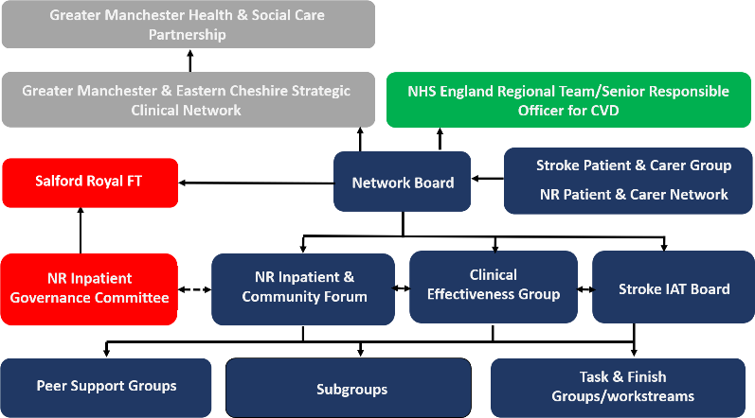

- Membership
The Board will chaired by the GMNISDN Hospital Clinical Director Co-Chair. Members have a responsibility to implement CEG decisions within their own organisations and to report progress back to the CEG.
Each member must identify a nominated deputy of sufficient seniority who shall attend only if the member is unavailable. Details of substitutions must be provided to the GMNISDN Manager in advance of meetings.
All members are required to abide by the network’s code of conduct for attendance at meetings (appendix 2).

Membership
GMNISDN Hospital Clinical Director (and Chair)
GMNISDN Manager and Facilitators
Each ASC’s Clinical Lead/Director for stroke and their Senior Manager
Representative from interventional neuro-radiology from the Comprehensive Stroke Centre
Representatives from radiology from each referring ASC

Additional members may be co-opted. Quorum will be achieved when at least 40% of Board members or nominees are present at Board meetings, which must include a Chair.

- Meetings
The Chair shall preside as chairperson at every Board meeting with GMNISDN Manager deputising as necessary. No business shall be transacted at any Board meeting unless a quorum of members is present. If quorum is not achieved within fifteen minutes from the time appointed the meeting may proceed but no formal decisions can be agreed as inquorate.
The frequency of meetings will be quarterly. Extraordinary meetings may be added for urgent business related matters.
Administrative support for the meetings will be provided by the GMNISDN. Papers for each meeting will be circulated no less than seven working days prior to the meeting. Formal minutes will be taken and circulated in draft form within 14 working days of each meeting. These minutes will be publicly available upon request, subject to appropriate consideration of any restricted/sensitive items. There will be no provision of funding for time or travel for members.

Appendix 1. National service model for stroke
Appendix 2. GMNISDN code of conduct for attendance at meetings

