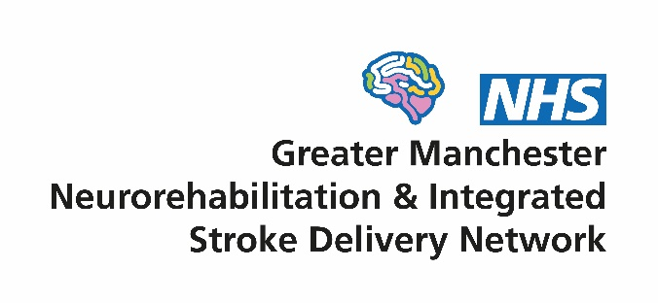

Training and Education Group
Terms of Reference

- Context
Since 2015, there have been two networks in Greater Manchester (GM) overseeing service improvement of the local neuro-rehabilitation (NR) and stroke pathways - the GM Neuro-rehabilitation Network (NRN) and the GM Integrated Stroke Delivery Network (ISDN). The significant overlap of the work programmes of two networks coupled with a funding shortfall in the NRN budget led to a decision at both network Boards in mid 2021 to merge the organisations into a single structure. The merged network will be called the GM Neuro Rehabilitation & Integrated Stroke Delivery Network (GMNISDN) and formally commenced on 1st October 2021.

- Vision
Supporting the development of high quality and equitable stroke and community NR services, to achieve the best outcomes and experience for patients. We will do this by:
- Being patient centred
- Working collaboratively with our stakeholders
- Facilitating transformational change through effective partnership working
- Encouraging the early adoption of evidence and innovation in our services

- Role of the Training & Education Subgroup
The group is a Subgroup of the GMNISDN Clinical Effectiveness Group. It will support the operational development and delivery of high quality, patient centred services for GM stroke and NR patients by ensuring the staff involved in delivering these services are appropriately professionally developed and well supported through training and educational opportunities.
The group will co-ordinate with national initiatives to improve the stroke workforce as part of NHS England’s Long Term Plan. It will also work regionally with other organisations focused on workforce development such as Health Education England.
The group will provide support for the delivery of introductory and experienced network training programmes and other eLearning packages. It will focus on providing leadership and oversight to support the development and implementation of a local workforce development strategy.
Members will be encouraged to be honest, open and respectful of others’ views, and act professionally whilst representing their organisations on the group.

- Membership
Membership will include representatives from acute and community stroke and NR services in GM. It will be flexible and inclusive but may be limited to one member per team/organisation depending on the size of the group. It will include NHS staff from different professional groups involved with stroke and NR care at different points of the pathway. Members from other stakeholders such as voluntary sector organisations and academia are also able to join the group. Involvement with other relevant bodies such as Health Education England, Public Health England, the Health & Social Care Partnership and Strategic Clinical Networks will be encouraged.
Two co-chairs (one from stroke, one from NR) will be appointed by the group to help facilitate and lead the meetings, working closely with the GMNISDN. Members have a responsibility to implement the subgroups decisions within their own organisations and to report progress back to the subgroup.
All members will be required to abide by the network’s code of conduct for attendance at meetings (appendix 1)

- Governance
The Training & Education Subgroup will report directly to the GMNISDN Clinical Effectiveness Group
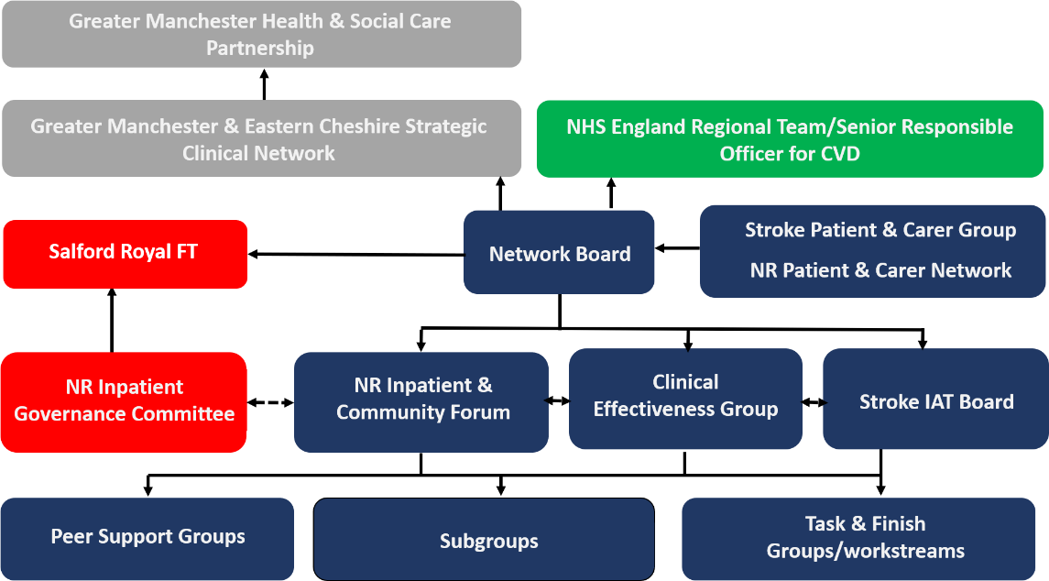

- Meetings
A Co-Chair shall preside as chairperson at every meeting. The frequency of meetings will be determined by the subgroup but will be no less than quarterly. Administrative support will be provided by the GMNISDN (organising the agenda, taking and sending out minutes, communicating meetings). Brief notes with action points should be taken at each meeting and a summary delivered at the next GMNISDN Clinical Effectiveness Group. There will be no provision of funding by the GMNISDN for time or travel for members.

Appendix 1. GMNISDN code of conduct for attendance at meetings

